UNIT-2

FOUNDATIONAL AREAS OF COGNITIVE SCIENCE

Introduction & Evolution of Cognitive Science: Introduction to the study of cognitive sciences, Brief history of cognitive science , development and Methodological concerns in philosophy.
Understand Brain and Sensory Motor Information: Fundamentals of Neuro Science, Processing of sensory information in the brain, and Brain Imaging Elements.
Language & Linguistic Knowledge: Background and details of Syntax & Semantics, Understanding of Generative Linguistic.
Memory & Processing: Theory of Information Processing, Fundamentals of Short-term Memory

INTRODUCTION: EXPLORING INNER SPACE
“The sciences have developed in an order the reverse of what might have been expected. What was most remote from ourselves was first brought under the domain of law, and then, gradually, what was nearer: first the heavens, next the earth, then animal and vegetable life, then the human body, and last of all (as yet very imperfectly) the human mind.”
—Bertrand Russell, 1935
A Brave New World

We are in the midst of a revolution. For centuries science has made great strides in our understanding of the external observable world. Physics revealed the motion of the planets, chemistry discovered the fundamental elements of matter, biology has told us how to understand and treat disease. But during much of this time, there were still many unanswered questions about something perhaps even more important to us. That something is the human mind. What makes mind so difficult to study is that, unlike the phenomena described above, it is not something we can easily observe, measure, or manipulate. In addition, the mind is the most complex entity in the known universe.
To give you a sense of this complexity consider the following.
- The human brain is estimated to contain ten billion to one hundred billion individual nerve cells or neurons. Each of these neurons can have as many as ten thousand connections to other neurons. This vast web is the basis of mind, and gives rise to all of the equally amazing and difficult-to-understand mental phenomena such as perception, memory, and language.
- The past several decades have seen the introduction of new technologies and methodologies for studying this intriguing organ. We have learned more about the mind in the past half-century than in all the time that came before that. This period of rapid discovery has coincided with an increase in the number of different disciplines—many of them entirely new—that study mind. Since then, a coordinated effort among the practitioners of these disciplines has come to pass. This interdisciplinary approach has since become known as cognitive science. Unlike the science that came before, which was focused on the world of external, observable phenomena, or “outer space,” this new endeavor turns its full attention now to the discovery of our fascinating mental world, or “inner space.”

WHAT IS COGNITIVE SCIENCE?
- Cognitive science can be roughly summed up as the scientific interdisciplinary study of the mind. Its primary methodology is the scientific method, although as we will see, many other methodologies also contribute.
- A hallmark of cognitive science is its interdisciplinary approach. It results from the efforts of researchers working in a wide array of fields. These include philosophy, psychology, linguistics, artificial intelligence, robotics, and neuroscience. Each field brings with it a unique set of tools and perspectives.
- One major goal of cognitive science is to show that when it comes to studying something as complex as the mind, no single perspective is adequate.
- Instead, intercommunication and cooperation among the practitioners of these disciplines tell us much more.
- Cognitive science refers not so much to the sum of all these disciplines but to their intersection or converging work on specific problems.
- In this sense, cognitive science is not a unified field of study like each of the disciplines themselves, but a collaborative effort among researchers working in the various fields. The glue that holds cognitive science together is the topic of mind and, for the most part, the use of scientific methods.
- In order to really understand what cognitive science is all about we need to know what its theoretical perspective on the mind is. This perspective centers on the idea of computation, which may alternatively be called information processing.
- Cognitive scientists view the mind as an information processor. Information processors must both represent and transform information. That is, a mind, according to this perspective, must incorporate some form of mental representation and processes that act on and manipulate that information.
- Cognitive science is often credited with being influenced by the rise of the computer. Computers are of course information processors. Think for a minute about a personal computer.
- It performs a variety of information processing tasks. Information gets into the computer via input devices, such as a keyboard or modem. That information can then be stored on the computer, for example, on a hard drive or other disk.
- The information can then be processed using software such as a text editor. The results of this processing may next serve as output, either to a monitor or printer. In like fashion, we may think of people performing similar tasks. Information is “input” into our minds

through perception—what we see or hear. It is stored in our memories and processed in the form of thought.
- Our thoughts can then serve as the basis of “outputs,” such as language or physical behavior. Of course, this analogy between the human mind and computers is at a very high level of abstraction.
- The actual physical way in which data is stored on a computer bears little resemblance to human memory formation. But both systems are characterized by computation. In fact, it is not going too far to say that cognitive scientists view the mind as a machine or mechanism whose workings they are trying to understand.

REPRESENTATION
- A concept stands for a single entity or group of entities. Single words are good examples of concepts.
- There are four crucial aspects of any representation (Hartshorne, Weiss & Burks, 1931– 1958).
  - First, a “representation bearer” such as a human or a computer must realize a representation.
  - Second, a representation must have content—meaning it stands for one or more objects.
  - The thing or things in the external world that a representation stands for are called referents. A representation must also be “grounded.” That is, there must be some way in which the representation and its referent come to be related.
  - Fourth, a representation must be interpretable by some interpreter, either the representation bearer him or herself, or somebody else. These and other characteristics of representations are discussed next. The fact that a representation stands for something else means it is symbolic.
We are all familiar with symbols. We know for instance that the symbol “$” is used to stand for money.
According to one view, a representation’s meaning is derived from the relationship between the representation and what it is about. The term that describes this relation is intentionality.
- Intentionality means “directed upon an object.” Mental states and events are intentional. They refer to some actual thing or things in the world. If you think about your brother, then the thought of your brother is directed toward him, not toward your sister, a cloud, or some other object.

DIGITAL REPRESENTATION
- In a digital representation, sometimes also known as a symbolic representation, information is coded in a discrete way with set values.
- It displays a separate number for each hour, minute, or year. There are distinct advantages to digital representations. They specify values exactly. The symbols used in digital representations, such as numbers, can be operated on by a more general set of processes than analog structures.
- In mathematics, a wide range of operators such as addition, division, or squaring can be applied to digital number representations. The results of these operations are new numbers that can themselves be transformed by additional operations.
- Language can serve as an example of a digital mental representation, and in fact verbal concepts seem to be the system of human symbolic representation that is most commonly used.
- The basic elements of written language are letters. These are discrete symbols that are combined according to a set of rules.
- The combinations, or words, have meaning and are themselves combined into other higher-order units, sentences, which also have semantic content. The rules by which these word elements are combined and transformed in language are called syntax.
- Syntax constitutes the set of permissible operations on the word elements. It is the elements themselves that are the mental representations. In the chapter on linguistics, we talk more about linguistic representations and syntax.

ANALOG REPRESENTATIONS
- Analog representations, in contrast, represent information in a continuous way. Information in an analog system can theoretically take on any value not limited by resolution.
- Resolution refers to the amount of detail contained in an analog representation. Representations with high resolution have correspondingly more information. An analog clock represents time through the movement of its various hands.
- Visual images are the best example of mental analog representations. Researchers in cognitive psychology have conducted numerous experiments that strongly suggest we represent visual information in an analog fashion. Stop reading for a moment and close your eyes.

THE DUAL-CODING HYPOTHESIS
- The use of both digital/symbolic and image representations collectively has been referred to as the dual-code hypothesis (Paivio, 1971). Alan Paivio believes that many ideas can be represented in either of these two forms interchangeably. This is especially true for a specific concrete concept, such as “elephant,” for which we can form a visual image or a verbal representation.
- However, there are some concepts for which a symbolic code seems more appropriate. Take the idea of “justice.” This is abstract, and although we could attach an image to it, such as that of a court building, there is no unambiguous and unique identifying image.
- Evidence in support of dual-code theory comes from studies in which better recall is demonstrated for words representing concrete concepts, as compared to words representing abstract concepts (Paivio, 1971).

PROPOSITIONAL REPRESENTATIONS
- Propositions are a third major category of representation, in addition to symbolic and imaginal codes (Pylyshyn, 1973).
- According to the propositional hypothesis, mental representations take the form of abstract sentence-like structures. Propositions are good at capturing the relationships between concepts.
- For example, the sentence “Mary looked at John” specifies a type of relationship between Mary and John, and that relationship can then be translated into either a verbal symbolic code, as in the actual form of a sentence, or an image code.
- A predicate calculus is a general system of logic that accurately expresses a large variety of assertions and modes of reasoning.
- The proposition “Mary looked at John” can be represented by a predicate calculus such as: [Relationship between elements] ([Subject element], [Object element]) where “Mary” is the subject element, “John” is the object element, and “looking” is the relationship between elements.
- What is nice about a predicate calculus is that it captures the essential logical structure of a complex idea independent of its actual elements. Any number of subjects, objects, and relationships can be inserted into the abstract format of a proposition. A proposition is thus believed to capture the basic meaning of a complex idea. This basic meaning, when translated back into a symbolic or visual code, can then be expressed in a variety of ways.

COMPUTATION
- As mentioned earlier, representations are only the first key component of the cognitive science view of mental processes.
- Representations by themselves are of little use unless something can be done with them. Having the concept of money doesn’t do much for us unless we know how to calculate a tip or can give back the correct amount of change to someone.
- In the cognitive science view, the mind performs computations on representations. It is therefore important to understand how and why these mental mechanisms operate. What sorts of mental operations does the mind perform?
- categories can be defined by the type of operation that is performed or by the type of information acted upon. An incomplete list of these operations would include sensation, perception, attention, memory, language, mathematical reasoning, logical reasoning, decision making, and problem-solving.

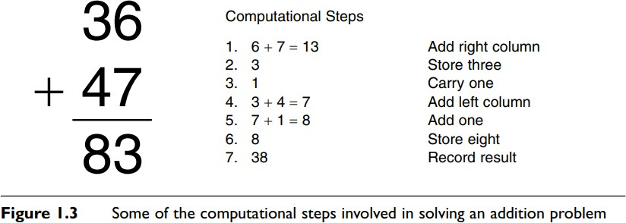

THE TRI-LEVEL HYPOTHESIS
Any given information process can be described at several different levels. According to the tri-level hypothesis, mental or artificial information-processing events can be evaluated on at least three different levels (Marr, 1982).
- The highest or most abstract level of analysis is the computational level. At this level, one is concerned with two tasks.
- The first is a clear specification of what the problem is. Taking the problem as it may have originally been posed, in a vague manner perhaps, and breaking it down into its main constituents or parts can bring about this clarity. It means describing the problem in a precise way such that the problem can be investigated using formal methods. It is like asking the questions:
- What exactly is this problem? What does this problem entail? The second task one encounters at the computational level concerns the purpose or reason for the process.
- The second task consists of asking: Why is this process here in the first place? Inherent in this analysis is the idea of adaptiveness—the idea that human mental processes are learned or have evolved to enable the human organism to solve a problem it faces. This is the primary explanatory perspective used in the evolutionary approach.
- Stepping down one level of abstraction, we can next inquire about the actual way in which an information process is carried out.
- To do this we need an algorithm, a formal procedure or system that acts on informational representations. It is important to note that algorithms can be carried out regardless of a representation’s meaning; algorithms act on the form, not the meaning, of the symbols they transform.
- One way to think of algorithms is that they are “actions” used to manipulate and change representations.
- Algorithms are formal, meaning they are well-defined. We know exactly what occurs at each step of an algorithm and how a particular step changes the information being acted on.
- A mathematical formula is a good example of an algorithm.
- A formula specifies how the data is to be transformed, what the steps are, and what the order of steps is. This type of description is put together at the algorithmic level, sometimes also called the programming level.
- It is equivalent to asking the question: What information-processing steps are being used to solve the problem? If we were to draw an analogy with computers, the algorithmic level is like software, because software contains instructions for the processing of data. The most specific and concrete type of description is formulated at the implementational level. Here we ask:
- Computers and humans can both perform addition, but do so in drastically different fashions. This is true at the implementational level obviously, but understanding the difference formally tells us much about alternative problem-solving approaches. It also gives us insights into how these systems might compute solutions to other novel problems that we might not understand.
- This partitioning of the analysis of information-processing events into three levels has been criticized as being fundamentally simplistic, since each level can in turn be further subdivided into levels (Churchland, Koch & Sejnowski, 1990).
- Figure 1.4 depicts one possible organization of the many structural levels of analysis in the nervous system.
- Starting at the top, we might consider the brain as one organizational unit; brain regions as corresponding to another organizational unit one step down in spatial scale; and then neural networks, individual neurons, and so on. Similarly, we could divide algorithmic steps into different sub-steps, and problems into sub-problems. To compound all this, it is not entirely clear how to map one level of analysis onto another.

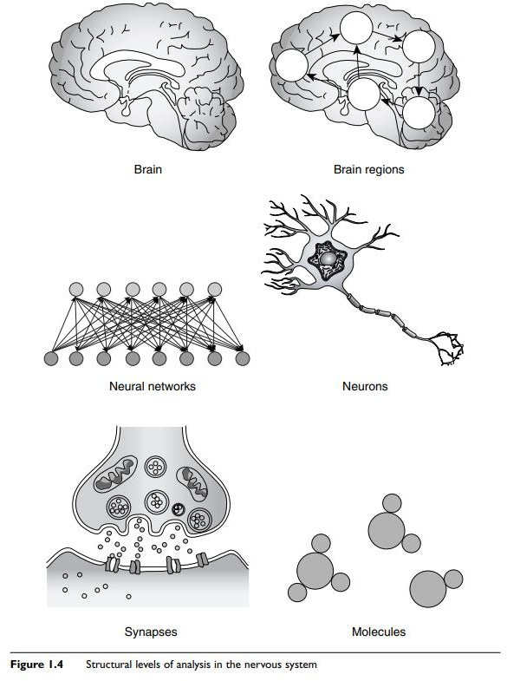

We may be able to clearly specify how an algorithm executes, but be at a loss to say exactly where or how this is achieved with respect to the nervous system.

THE CLASSICAL AND CONNECTIONIST VIEWS OF COMPUTATION
- A system is formal if it is syntactic or rule governed. The rules of language and mathematics are formal systems because they specify which types of allowable changes can be made to symbols.
- Formal systems also operate on representations independent of the content of those representations. In other words, a process can be applied to a symbol regardless of its meaning or semantic content.
- A symbol, as we have already indicated, is a form of representation and can assume a wide variety of forms. Manipulation here implies that computation is an active, embodied process that takes place over time.
- In the classical view, knowledge is represented locally, in the form of symbols. In the connectionist view knowledge is represented as a pattern of activation or weights that is distributed throughout a network.
- Processing style is also different in each approach. The classical view has processing occurring in discrete stages, whereas in connectionism, processing occurs in parallel through the simultaneous activation of nodes.
Some cognitive scientists downplay these differences, arguing that information processing occurs in both systems and that the tri-level hypothesis can be applied equally to both (Dawson, 1998).

SELF ASSESSMENT (2M)

- What is Cognitive Science?
- Differentiate Mind and Brain
- What is the role of Cognitive Scientist in solving complex and unstructured problems in real-time?
- What is taught?
- Illustrate the features of cognitive science.
- What is the need of computation in tri-level hypothesis?
- Define the term Algorithm in cognitive sense.

HISTORY OF COGNITIVE SCIENCE

- Cognitive Science: History- The roots of cognitive science extend back far in intellectual history, but its genesis as a collaborative endeavor of psychology, computer science, neuroscience, linguistics, and related fields lies in the 1950s. Its first major institutions (a journal and society) were established in the late 1970s. This history describes relevant developments within each field and traces collaboration between the fields in the last half of the twentieth century.
- A key contributor to the emergence of cognitive science, psychologist George Miller, dates its birth to September 11, 1956, the second day of a Symposium on Information Theory at MIT.
- Computer scientists Allen Newell and Herbert Simon, linguist Noam Chomsky, and Miller himself presented work that would turn each of their fields in a more cognitive direction. Miller left the symposium ‘with a strong conviction, more intuitive than rational, that human experimental psychology, theoretical linguistics, and the computer simulation of cognitive processes were all pieces from a larger whole, and that the future would see a progressive elaboration and coordination of their shared concerns’ (Miller 1979).
- This early conference illustrates an enduring feature of cognitive science—it is not a discipline in its own right, but a multidisciplinary endeavor. Although a few departments of cognitive science have been created at universities in subsequent decades, most of its practitioners are educated and spend their careers in departments of the contributing disciplines. The relative prominence of these disciplines has varied over the years.
- Computer science and psychology have played a strong role throughout. Neuroscience initially was strong, but in the years immediately following the 1956 conference its role declined as that of linguistics dramatically increased. By the 1970s, such disciplines as philosophy, sociology, and anthropology were making distinctive contributions. Recently, with the emergence of cognitive neuroscience, neuroscience has once again become a central contributor.

THE INTERDISCIPLINARY PERSPECTIVE OF COGNITIVE SCIENCE
There is an old fable about five blind men who stumble upon an elephant (see Figure 1.5). Not knowing what it is, they start to feel the animal. One man feels only the elephant’s tusk and thinks he is feeling a giant carrot. A second man,

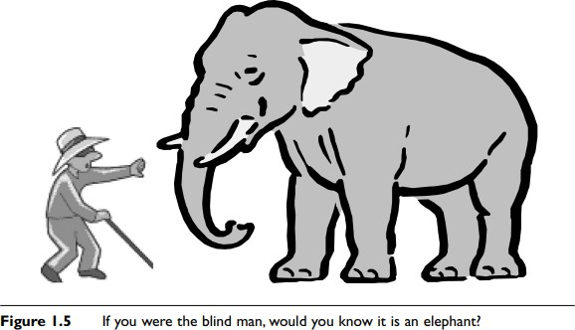

feeling the ears, believes the object is a big fan. The third feels the trunk and proclaims it is a pestle, while a fourth touching only the leg believes it is a mortar. The fifth man, touching the tail, has yet another opinion: he believes it to be a rope. Obviously, all five men are wrong in their conclusions because each has only examined one aspect of the elephant. If the five men had gotten together and shared their findings, they may have easily pieced together what kind of creature it was. This story serves as a nice metaphor for cognitive science.

- We can think of the elephant as the mind and the blind men as researchers in different disciplines in cognitive science. Each individual discipline may make great strides in understanding its particular subject matter, but, if it cannot compare its results to those of other related disciplines, may miss out on understanding the real nature of what it is that is being investigated.
- The key, then, to figuring out something as mysterious and complex as mind is communication and cooperation among disciplines. This is what’s meant when one talks about cognitive science—not the sum of each of the disciplines or approaches, but their union.
- Recent years have seen an increase in this cooperation. A number of major universities have established interdisciplinary cognitive science centers, where researchers in such diverse areas as philosophy, neuroscience, and cognitive psychology are encouraged to work together on common problems. Each area can then contribute its unique strength to the phenomenon under study.
- The philosophers can pose broad questions and hypotheses, the neuroscientists can measure physiological performance and brain activity, while the cognitive psychologists can design and carry out experiments.
- The consequent exchange of results and ideas then leads to fruitful synergies between these disciplines, accelerating progress with respect to finding solutions to the problem and yielding insights into other research questions. We have alluded to some of the different approaches in cognitive science. Because this book is about explaining each approach and its major theoretical contributions, it is worth describing each now in terms of its perspective, history, and methodology. In the following sections we will also provide a brief preview of the issues addressed by each approach.

PHILOSOPHICAL APPROACH

Philosophy is the oldest of all the disciplines in cognitive science. It traces its roots back to the ancient Greeks.
Philosophers have been active throughout much of recorded human history, attempting to formulate and to answer basic questions about the universe. This approach is free to study virtually any sort of important question on virtually any subject, ranging from the nature of existence to the acquisition of knowledge, to politics, ethics, and beauty.
Philosophers of mind narrow their focus to specific problems concerning the nature and the characteristics of mind. They might ask questions like: What is mind? How do we come to know things?
How is mental knowledge organized? The primary method of philosophical inquiry is reasoning, both deductive and inductive. Deductive reasoning involves the application of the rules of logic to statements about the world. Given an initial set of statements assumed to be true, philosophers can derive other statements that logically must be correct.
For example, if the statement “College students’ study three hours every night” is true and the statement “Mary is a college student” is true, we can then conclude that “Mary will study three hours every night.”
Philosophers also engage in inductive reasoning. They make observations about specific instances in the world, notice commonalities among them, and draw conclusions.
An example of inductive reasoning would be: “Whiskers the cat has four legs,” “Scruffy the cat has four legs,” therefore “All cats have four legs.” However, philosophers do not use a systematic form of induction known as the scientific method. That is employed within the other cognitive science disciplines.
With respect to the mind-body problem, philosophers wrangle over what exactly a mind is. Is the mind something physical like a rock or a chair, or is it nonphysical?
Can minds exist only in brains or can they emerge from the operation of other complex entities such as computers? In the free will–determinism debate we explore whether our actions can ever be completely known and/or predicted beforehand.
The knowledge acquisition problem deals with how we come to know things. Is knowledge a product of one’s genetic endowment or does it arise through one’s interaction with the environment?

How much does each of these factors contribute to any given mental ability? We also look into one of the most fascinating and enigmatic mysteries of mind, that of consciousness. What is consciousness? Are we really conscious at all?

THE PSYCHOLOGICAL APPROACH
Compared to philosophy, psychology is a relatively young discipline. It can be considered to be old though, particularly when it is compared to some of the more recent newcomers to the cognitive science scene, for example, artificial intelligence and robotics. Psychology arose in the late 19th century and was the first discipline in which the scientific method was applied exclusively to the study of mental phenomena.
Early psychologists established experimental laboratories that would enable them to catalog mental ideas and to investigate various mental capacities, such as vision and memory. Psychologists apply the scientific method to both mind and behavior.
That is, they attempt to understand not just internal mental phenomena, such as thoughts, but also the external behaviors that these internal phenomena can give rise to.
The scientific method is a way of getting hold of valid knowledge about the world. One starts with a hypothesis or idea about how the world works and then designs an experiment to see if the hypothesis has validity.
In an experiment, one essentially makes observations under a set of controlled conditions.
The resulting data then either support or fail to support the hypothesis.
The field of psychology is broad and encompasses many subdisciplines, each one having its unique theoretical orientations.
Each discipline has a different take on what mind is. The earliest psychologists, that is, the voluntarists and structuralists, viewed the mind as a kind of test tube in which chemical reactions between mental elements took place. In contrast, functionalism viewed mind not according to its constituent parts, but according to what its operations were—what it could do.
The Gestaltists again went back to a vision of mind as composed of parts, but emphasized that it was the combination and interaction of the parts, which give rise to new wholes, that was important.
Psychoanalytic psychology conceives of mind as a collection of competing entities, while behaviorism sees it as a device that maps stimuli onto behaviors.

THE COGNITIVE APPROACH
Starting in the 1960s a new form of psychology arrived on the scene. Known as cognitive psychology, it came into being in part as a backlash against the behaviorist movement and its profound emphasis on behavior.

Cognitive psychologists placed renewed emphasis on the study of internal mental operations. They adopted the computer as a metaphor for mind, and described mental functioning in terms of representation and computation. They believed that the mind, like a computer, could be understood in terms of information processing.
The cognitive approach was also better able to explain phenomena such as language acquisition, for which behaviorists did not have good accounts. At around the same time, new technologies that allowed better measurement of mental activity were being developed.
This promoted a movement away from the behaviorist’s emphasis on external observable behaviors toward the cognitive scientist’s emphasis on internal functions, as these could, for the first time, be observed with reasonable precision.
Inherent in the cognitive approach is the idea of modularity. Modules are functionally independent mental units that receive inputs from other modules, perform a specific processing task, and pass the results of their computation onto yet additional modules.
The influence of the modular approach can be seen in the use of process models or flow diagrams. These depict a given mental activity via the use of boxes and arrows, where boxes depict modules and arrows the flow of information among them.
The techniques used in this approach are the experimental method and computational modeling. Computational modeling involves carrying out a formal (typically software based) implementation of a proposed cognitive process.
Researchers can run the modeling process so as to simulate how the process might operate in a human mind. They can then alter various parameters of the model or change its structure in an effort to achieve results as close as possible to those obtained in human experiments. This use of modeling and comparison with experimental data is a unique characteristic of cognitive psychology and is also used in the artificial intelligence and network approaches.
Cognitive psychologists have studied a wide variety of mental processes. These include pattern recognition, attention, memory, imagery, and problem solving.

THE NEUROSCIENCE APPROACH
Brain anatomy and physiology have been studied for quite some time. Recent times however have seen tremendous advances in our understanding of the brain, especially in terms of how neuronal processes can account for cognitive phenomena.
The general study of the brain and endocrine system is called neuroscience. The attempt to explain cognitive processes in terms of underlying brain mechanisms is known as cognitive neuroscience.
Neuroscience, first and foremost, provides a description of mental events at the implementational level. It attempts to describe the biological “hardware” upon which mental “software” supposedly runs.

However, as discussed above, there are many levels of scale when it comes to describing the brain, and it is not always clear which level provides the best explanation for any given cognitive process.
Neuroscientists, however, investigate at each of these levels. They study the cell biology of individual neurons and of neuron-to-neuron synaptic transmission, the patterns of activity in local cell populations, and the interrelations of larger brain areas.
A reason for many of the recent developments in neuroscience is, again, the development of new technologies. Neuroscientists employ a wide variety of machines to measure the performance of the brain at work. These include positron emission tomography (PET) scanners, computerized axial tomography (CAT) scanners, and magnetic resonance imaging (MRI) machines.
Studies that use these devices have participants perform a cognitive task; the brain activity that is concurrent with the performance of the task is recorded. For example, a participant may be asked to form a visual image of a word that appears on a computer screen.
The researchers can then determine which parts of the brain became active during imagery and in what order. Neuroscientists use other techniques as well. They study brain-damaged patients and the effects of lesions in laboratory animals, and use single- and multiple-cell recording techniques.

THE NETWORK APPROACH
The network approach is at least partially derived from neuroscience. In this perspective, mind is seen as a collection of individual computing units.
These units are connected to one another and mutually influence one other’s activity via the connections.
Although each of the units is believed to perform a relatively simple computation, for example, a neuron’s either firing or not firing, the connectivity of the units can give rise to representational and computational complexity.
The first involves the construction of artificial neural networks. Most artificial neural networks are computer software simulations that have been designed to mimic the way actual brain networks operate, or the functioning of neural cell populations. Artificial neural networks that can perform arithmetic, learn concepts, and read out loud now exist.
A wide variety of network architectures have developed over the last thirty years. The second part of the network chapter is more theoretical and focuses on knowledge representation—on how meaningful information may be mentally coded and processed.
In semantic networks, nodes standing for concepts are connected to one another in such a way that activation of one node causes activation of other related nodes.
- Semantic networks have been constructed to explain how conceptual information in memory is organized and recalled. They are often used to predict and explain data obtained from experiments with human participants in cognitive psychology.

THE EVOLUTIONARY APPROACH
The theory of natural selection proposed by Charles Darwin in 1859 revolutionized our way of thinking about biology. Natural selection holds that adaptive features enable the animals that possess them to survive and pass these features on to future generations.
The environment in this view is seen as selecting from among a variety of traits those that serve a functional purpose. The evolutionary approach can be considered in a quite general way and used to explain phenomena outside of biology.
The field of evolutionary psychology applies selection theory to account for human mental processes.
It attempts to elucidate the selection forces that acted on our ancestors and how those forces gave rise to the cognitive structures we now possess. Evolutionary psychologists also adopt a modular approach to mind.
In this case, the modules correspond to “favored” cognitive capacities that were used by ancestors successful at solving certain problems.
Evolutionary theories have been proposed to account for experimental results across a wide range of capacities, from categorization to memory, to logical and probabilistic reasoning, language, and cognitive differences between the sexes.
A variant on this theme is evolutionary computing, in which the rules of evolution are applied to create successful computer algorithms. An offshoot of this form of computing is artificial life. These are software simulations that mimic biological ecosystems. There is also neural Darwinism, which uses evolution to explain the formation of neural circuits.

THE LINGUISTIC APPROACH
Linguistics is an area that focuses exclusively on the domain of language. It is concerned with all questions concerning language ability, such as: What is language? How do we acquire language?
What parts of the brain underlie language use? As we have seen, language is a topic studied within other disciplines, for example, cognitive psychology and neuroscience. Because so many different researchers in different disciplines have taken on the problem of language, we consider it here as a separate discipline, united more by topic than by perspective or methodology.
Part of the difficulty in studying language is the fact that language itself is so complex. Much research has been devoted to understanding its nature. This work looks at the properties all languages share, the elements of language, and how those elements are used during communication.

Other foci of linguistic investigation center on primate language use, language acquisition, deficits in language acquisition caused by early sensory deprivation or brain damage, the relationship between language and thought, and the development of speech recognition systems.
Linguistics, perhaps more than any other perspective discussed here, adopts a very eclectic methodological approach.
Language researchers employ experiments and computer models, study brain-damaged patients, track how language ability changes during development, and compare diverse languages.

THE ARTIFICIAL INTELLIGENCE APPROACH
Researchers have been building devices that attempt to mimic human and animal function for many centuries. But it is only in the past few decades that computer scientists have seriously attempted to build devices that mimic complex thought processes. This area is now known as artificial intelligence (AI).
Researchers in AI are concerned with getting computers to perform tasks that have heretofore required human intelligence. As such they construct programs to do the sorts of things that require complex reasoning on our part. AI programs have been developed that can diagnose medical disorders, use language, and play chess.
AI secondarily gives us insights into the function of human mental operations. Designing a computer program that can visually recognize an object often proves useful in understanding how we may perform the same task ourselves. An even more exciting outcome of AI research is that someday we may be able to create an artificial person who will possess all or many of the features that we consider uniquely human, such as consciousness, the ability to make decisions, and so on.
It is the development of computer algorithms and their testing, their comparison with empirical data or performance standards, and their subsequent modification that constitute the methodology of the AI perspective. Not all computer programs are alike, however.
Researchers have employed a wide range of approaches. An early attempt at getting computers to reason involved the application of logical rules to propositional statements. Later on, expert systems, scripts, and fuzzy logic procedures, among others, were used.

THE ROBOTICS APPROACH
Finally, we consider robotics. Robotics may be considered a familial relation to AI and has appeared on the scene as a formal discipline just as recently. Whereas AI workers build devices that “think,” robotics researchers build machines that must also “act.”

Investigators in this field build autonomous or semi-autonomous mechanical devices that have been designed to perform a physical task in a real-world environment.
Examples of things that robots can do presently include navigating around a cluttered room, welding or manipulating parts on an assembly line, and defusing bombs. The robotics approach has much to contribute to cognitive science and to theories of mind. Robots, like people and animals, must demonstrate successful goal-oriented behaviors under complex, changing, and uncertain environmental conditions.
Robotics therefore helps us to think about the kinds of minds that underlie and produce such behaviors.
The hierarchical paradigm offers a “top down” perspective, according to which a robot is programmed with knowledge about the world. The robot then uses this model or internal representation to guide its actions.
The reactive paradigm, on the other hand, is “bottom up.” Robots that use this architecture respond in a simple way to environmental stimuli: they react reflexively to a stimulus input and there is little in the way of intervening knowledge.

IN DEPTH: CATEGORIES OF MENTAL REPRESENTATION
We have said that there are three broad classes of mental representation— digital, analog, and propositional—each having its own characteristics, and we gave examples of each. However, the history of research in cognition suggests that there are also numerous forms of mental representation.
Paul Thagard, in Mind: Introduction to Cognitive Science (2000), proposes four. These are concepts, propositions, rules, and analogies. Although some of these have already been alluded to and are described elsewhere in the book, they are central to many ideas in cognitive science.
It is therefore useful to sketch out some of their major characteristics here. A concept is perhaps the most basic form of mental representation. A concept is an idea that represents things we have grouped together.
The concept “chair” does not refer to a specific chair, such as the one you are sitting in now, but is more general than that. It refers to all possible chairs no matter what their colors, sizes, and shapes.
Concepts need not refer to concrete items. They can stand for abstract ideas, for example, “justice” or “love.”
Concepts can be related to one another in complex ways. They can be related in a hierarchical fashion, where a concept at one level of organization stands for all members of the class just below it.
“Golden retrievers” belongs to the category of “dogs,” which in turn belongs to the category of “animals.”

The question of whether concepts are innate or learned is discussed in the philosophical approach chapter. The artificial intelligence chapter outlines the use of structures called frames as a means of representing conceptual knowledge.
A proposition is a statement or assertion typically posed in the form of a simple sentence. An essential feature of a proposition is that it can be proved true or false. For instance, the statement “The moon is made out of cheese” is grammatically correct and may
represent a belief that some people hold, but it is a false statement.
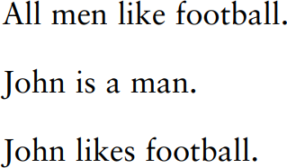
We can apply the rules of formal logic to propositions to determine the validity of those propositions. One logical inference is called a syllogism. A syllogism consists of three propositions. The first two are premises and the last is a conclusion. Take the following syllogism
Obviously, the conclusion can be wrong if either of the two premises is wrong. If it is not true that all men like football, then it might not be true that John likes football, even if he is a man.
If John is not a man, then he may or may not like football, assuming all men like it. Syllogistic reasoning of this sort is the same as deductive reasoning, mentioned earlier. You may have noticed that propositions are representations that incorporate concepts.
The proposition “All men like football” incorporates the concepts “men” and “football.”
Propositions are more sophisticated representations than concepts because they express relationships, sometimes very complex ones, between concepts.
The rules of logic are best thought of as computational processes that can be applied to propositions in order to determine their validity. However, logical relations between propositions may themselves be considered a separate type of representation.
The evolutionary approach chapter provides an interesting account of why logical reasoning, which is difficult for many people, is easier under certain circumstances. Logic is not the only system for performing operations on propositions. Rules do this as well.
A production rule is a conditional statement of the form: “If x, then y,” where x and y are propositions. The “if” part of the rule is called the condition. The “then” part is called the action. If the proposition that is contained in the condition (x) is true, then the action that is specified by the second proposition (y) should be carried out, according to the rule. The following rules help us drive our cars:

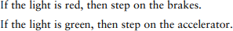
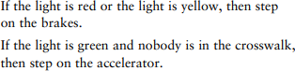
Notice that, in the first rule, the two propositions are “the light is red” and “step on the brakes.” We can also form more complex rules by linking propositions with “and” and “or” statements
The “or” that links the two propositions in the first part of the rule specifies that if either proposition is true, the action should be carried out. If an “and” links these two propositions, the rule specifies that both must be true before the action can occur.
Rules bring up the question of what knowledge really is. We usually think of knowledge as factual. Indeed, a proposition such as “Candy is sweet,” if validated, does provide factual information.
The proposition is then an example of declarative knowledge. Declarative knowledge is used to represent facts. It tells us what is and is demonstrated by verbal communication.
Procedural knowledge, on the other hand, represents skill. It tells us how to do something and is demonstrated by action. If we say that World War II was fought during the period 1939–1945, we have demonstrated a fact learned in history class.
If we ski down a snowy mountain slope in the winter, we have demonstrated that we possess a specific skill. It is therefore very important that information-processing systems have some way of representing actions if they are to help an organism or machine to perform those actions.
Rules are one way of representing procedural knowledge. We discuss two cognitive rule- based systems, the Atomic Components of Thought (ACT) and SOAR models, in the cognitive approach chapters. Another specific type of mental representation is the analogy, although, as is pointed out below, the analogy can also be classified as a form of reasoning.
Thinking analogically involves applying one’s familiarity with an old situation to a new situation.
Suppose you had never ridden on a train before, but had taken buses numerous times. You could use your understanding of bus riding to figure out how to take a ride on a train.
Applying knowledge that you already possess and that is relevant to both scenarios would enable you to accomplish this. Based on prior experience, you would already know that you have to first determine the schedule, perhaps decide between express and local service, purchase a ticket, wait in line, board, stow your luggage, find a seat, and so on.

Analogies are a useful form of representation because they allow us to generalize our learning. Not every situation in life is entirely new. The application of the analogical
approach in artificial intelligence is called case-based reasoning

SELF ASSESSMENT

- Explain the Interdisciplinary Study of Cognitive Science? (4M)
OR
- Elaborate the history of Cognitive Science (4/8M)

DEVELOPMENT AND METHODOLOGICAL CONCERNS IN PHILOSOPHY

Philosophy as Methodology
- The general concept of methodology. The world presents us with a picture of an infinite diversity of properties, connections and events. This kaleidoscope of impressions must be permeated by an organising principle, a certain method, that is to say, by certain regulative techniques and means of the practical and theoretical mastering of reality.
- Practical and theoretical activities follow different methods. The former indicate the ways of doing things and corresponding human skills that have been historically formed and socially established in the instruments of labour. The latter characterise the modes of activity of the mind resulting in the finding truth and the correct, rational solution of problems.
- A methodology is a system of principles and general ways of organising and structuring theoretical and practical activity, and also the theory of this system.
- Genetically methods go back far into the past, when our distant ancestors were acquiring, generalising and handing down to new generations their skills and means of influencing nature, the forms of organising labour and communication. As philosophy emerged, methodology became a special target of cognition and could be defined as a system of socially approved rules and standards of intellectual and practical activity.
- These rules and standards had to be aligned with the objective logic of events, with the properties and laws of phenomena. The problems of accumulating and transmitting experience called for a certain formalisation of the principles and precepts, the techniques and operations involved in activity itself.
- With the development of production, technology, art, and the elements of science and culture, methodology becomes the target of theoretical thought, whose specific form is the Philosophical comprehension of the principles of organisation and regulation of cognitive activity, its conditions, structure and content.
- For example, in the work of Heraclitus "knowledge of many things" is contrasted to reason, the latter being a Particularly reliable means of understanding the dialectics of the universe--the universal Logos--and to be distinguished from the diversity of the "opinions" and legends acquired by unreliable means.
- The rules of reasoning, of effective proof, the role of language as a means of cognition were the subject of special inquiry in the philosophy of the Greek Sophists (Protagoras and others).
- Socrates, Plato and Aristotle occupy a special place in discussion of the problems of methodology. Socrates, for example, gave priority to the dialogical nature of thinking as the joint attainment of truth through collation of different notions and concepts, their comparison, analysis, definition and so on.
- He regarded his theory of Proceeding by means of induction from vague notions to clearly defined general concepts as a method of Perfecting the art of living, of achieving virtue; logical operations were subordinated to ethical aims.
- According to Socrates, the acquisition of true knowledge should serve action with a moral purpose.
- The purpose should be determined by means of appropriately organised work of the intellect. This Socratic principle had a deep influence on various trends in the evolution of methodology, especially on the teaching of Plato, who developed a dialectic of concepts and categories the purpose of which was to find the principle in everything. In order to achieve this, our thoughts should move according to the objective logic of the objects under consideration as the embodiments of incorporeal essences. The world of these essences, or ideas, was also regarded as a realm of beauty, of the good which the soul could attain through strenuous effort.
- Assuming like Plato that the object of true knowledge was the universal, Aristotle taught that this universal was to be discovered by investigating individual, empirically given things.
- The methodology of such research is set forth in Aristotle's logic, which closely analyses the principles for defining a term or constructing a statement, the rules of inference and proof, the role of induction and deduction in attaining truth, and so on.
- Aristotle's aesthetics expounds the principles of creativity and analysis in works of art. He also gives us a methodologically important elaboration of the theory of categories as the organising forms of cognition and their dialectics.
- Until modern times, however, the problems of methodology had no independent place in the system of knowledge and arose only in the context of logical and natural philosophical arguments. Scientific progress is not limited to the accumulation of knowledge. It is also a process of evolving new means of seeking knowledge.
- The rapid advance of natural science called for radical changes in methodology. This need was reflected in new principles of methodology and corresponding philosophical ideas, both rationalistic and empirical, directed against scholasticism.
- The principles of mechanics marked a breakthrough in methodology. According to Galileo, scientific knowledge, by uniting the inductive and deductive methods, should be based on planned, accurate mental and practical experiment.
- In Descartes the problem of methodology is central. Methodology is required to establish on what basis and by what methods new knowledge may be obtained. Descartes worked out the rules of the rationalistic method, the first rule being the demand that only propositions that are clearly and distinctly comprehensible may be accepted as true.
- The first principles are axiomatic knowledge, that is, ideas perceived intuitively by reason, without any proof. From these immediately perceived propositions new knowledge is deduced by means of deductive proof. This assumes the breaking down of complex problems into more specific and comprehensible problems and a strictly logical advance from the known to the unknown.
- Another line in methodology was represented at this time by English empiricism, which sought to devise modes of thought that would help to build a strictly experimental science guided by proofs of scientific truths arrived at through induction.
- The limitations of both trends were revealed by German classical philosophy, which produced a searching analysis of the conditions of cognition, its forms and organising principles. In contrast to mechanistic methodology, which metaphysically interpreted the ways and means of cognition, classical German Philosophy developed a dialectical methodology in idealistic forms.
- The relationship between theory and method. Whereas theory is the result of a process of cognition that reproduces a certain fragment of existence, methodology is a way of obtaining and building up such knowledge. Theory characterises knowledge itself, its structure, content and the degree to which it corresponds to the object; method characterises the activity involved in acquiring knowledge. It characterises the conditions for obtaining true knowledge.
- In practice, the distinction between theory and method may sometimes be functional: having taken shape as a theoretical result of past inquiry, method acts as the point of departure and condition for further investigation. Thus the law of the conservation of matter and energy as a theoretical principle expressing the fundamental condition for the existence of the world is simultaneously a methodological requirement for the investigation of any phenomenon.
- The methodological principle of the determinist explanation of the world is the organising principle of the corresponding physical, biological and social theories. After being tested by social practice, these theories in their turn may perform a methodological function, that is, serve as a guiding principle in further research.
- The need thus arises not only to pool the efforts of specialists in various fields, but also to combine scientific data in situations where there is in principle no complete or definite information about the object as a whole, as a system.
- Modern science is becoming more abstract and lends itself more easily to mathematical methods of research. Particularly relevant are the problems of interpreting the results of research performed with an extensive use of formalisation techniques. This has led to the special elaboration of methods interpretation and modelling.
- There are several classifications of methodological knowledge. One of the most popular is the division of methodology into substantive and formal methodology. The former includes such problems as the structure of scientific knowledge in general and scientific theory in particular, the laws of the generation, functioning and mutation of scientific theories, the conceptual framework of science and its separate disciplines, the definition of the explanatory patterns accepted in science, the structure and Operational composition of the methods of science, the conditions and criteria of scientificalness.
- The formal aspects ,of methodology are related to analysis of the language of science, the formal structure of scientific explanation, description and analysis of formal and formalised methods of research, particularly the methods of constructing scientific theories and conditions of their logical truth, the typology of systems of knowledge, and so on. It was the elaboration of this set of problems that raised the question of the logical structure of scientific knowledge and the development of a methodology of science as an independent field of knowledge.
- This field embraces the whole diversity of methodological and methodic principles and techniques, operations and forms of constructing scientific knowledge, Its highest and definitive level is the philosophical methodology, whose guiding principles organise methodological work both at the general scientific level (including the logico-methodological apparatus applicable to many disciplines) and at the specialised scientific level, Where special methods of research and derivative specific methodical systems are devised and applied.
- Method is concretised methodology. Through the method of the concrete science it reaches the research desk. The concrete sciences, which are specific in relation to philosophy, may in their turn be methodological in relation to the narrower fields of their specific sphere of knowledge.
- For example, general biology arms botany, zoology and other narrower disciplines with general methods of research. Relying on Philosophy, general biology works out the methodological problems related to all the departments of biological science. This principle is to be found in other sciences as well.
- According to another classification, methods are divided into philosophical, general scientific, and special scientific methods. Yet another classification relies on different methods of qualitative and quantitative study of reality. The distinction between methods depending on the forms of causality—determinist and probability methods—is of considerable importance in modern science.
- For example, in biology dialectics is seen through the prism of general scientific methods (systems analysis, the principles of self-regulation, etc.), in specific research projects through apply ing special scientific methods and systems of methods (electronic microscopy, the method of tagged atoms, etc.). One or another method makes it possible to know only separate aspects of the object of research. In order to comprehend all the essential aspects of the object, there must be complementarity of methods.
- The whole system of methodological knowledge necessarily involves a world-view interpretation of the basis of the research and its results. It should be stressed that general methodology is always at work in the brain of every scientist but, as a rule, it is kept in obscurity, as the intellectual background of a searching mind. This obscurity is sometimes so complete that the scientist may even deny that he acts according to any philosophical methodology, and insist that he is in general free of any philosophy. But this is merely an illusion of the consciousness.
- What makes us human? Less grandiosely: what distinguishes human cognition and action from the behavior of other animals?1 We talk, accumulate culture, cooperate with strangers, and other things that non-human animals do not clearly replicate. It seems plausible that some unique cognitive capacities might account for this peculiar behavior. Here the trouble starts: scientific inquiry keeps showing us how smart animals are and how animal we are.
- Specific claims to cognitive specialness tend to wilt under scientific scrutiny, and puzzles emerge from the most cursory survey of findings. What is supposed to set us apart, anyway?
- Is it possession of first order mental states, like beliefs and desires? Most likely not.
- A capacity to reflect on our own mental states? No: rats can do that, too. Recursive syntax, and an ability to learn syntactic rules? Birds have both, apparently. An ability to deploy concepts? Humans have the most conceptual acumen, but other animals acquire concepts, too. Findings like these are provisional: interpreting experimental results is not straightforward, and we can dispute any given conclusion. The trend, however, seems unmistakable: prospects for human specialness are dimming, not brightening.
- There is tension, then, between the claim that we are special and the naturalistic understanding of human and animal cognition that we achieve through scientific inquiry. We cannot resolve this tension by appealing to some putative non-natural, uniquely human characteristic. A characteristic is “non-natural” in the sense I intend just in case it is impossible to account for it within the scope of standard scientific inquiry, which supplies what I take to be paradigmatically naturalistic explanations.
- Humans, according to Aristotle, are capable of some special brand of cognition. Call this RATIONAL cognition, and say that animals capable of rational cognition have RATIONALITY. RATIONALITY (which Aristotle variously refers to as nous or, in some important cases, logos) 8 grants the creature a set of special cognitive capabilities. How are we to characterize these capabilities? What are we looking for? It is conventional to assume that we should understand RATIONALITY in terms of certain high-level cognitive achievements, such as scientific knowledge (epist^em^e), understanding (nous) 9 and practical wisdom (phron^esis).
- Aristotle devotes much attention to such cognition, which makes it tempting to conclude that they comprise the only human cognition that he cares about.
SELF ASSESSMENT
- Explain the Developmental and methodological concerns of philosophy. (8M)
OR
Explain the Philosophy of Aristotle.
OR
Illustrate the key role functioning of Philosophy in Cognitive science.

NOTE: Above 3 Questions have Same Answer

UNDERSTAND BRAIN AND SENSORY MOTOR INFORMATION: FUNDAMENTALS OF NEURO SCIENCE, PROCESSING OF SENSORY INFORMATION IN THE BRAIN, AND BRAIN IMAGING ELEMENTS.

INTRODUCTION TO THE STUDY OF BRAIN

Our brains are a central processing unit for everything we do. But how do our brains relate to our bodies? Are they connected or separate? Do our brains define who we are? An ancient legend from India (Rosenzweig & Leiman, 1989) tells of Sita. She marries one man but is attracted to another. These two frustrated men behead themselves. Sita, bereft of them both, desperately prays to the goddess Kali to bring the men back to life. Sita is granted her wish. She is allowed to reattach the heads to the bodies. In her rush to bring the two men back to life, Sita mistakenly switches their heads. She attaches them to the wrong bodies. Now, to whom is she married? Who is who? The mind–body issue has long interested philosophers and scientists.
Where is the mind located in the body, if at all? How do the mind and body interact?
How are we able to think, speak, plan, reason, learn, and remember? What are the physical bases for our cognitive abilities?
These questions all probe the relationship between cognitive psychology and neurobiology. Some cognitive psychologists seek to answer such questions by studying the biological bases of cognition.
Cognitive psychologists are especially concerned with how the anatomy (physical structures of the body) and the physiology (functions and processes of the body) of the nervous system affect and are affected by human cognition.
Cognitive neuroscience is the field of study linking the brain and other aspects of the nervous system to cognitive processing and, ultimately, to behavior. The brain is the organ in our bodies that most directly controls our thoughts, emotions, and motivations.
We usually think of the brain as being at the top of the body’s hierarchy—as the boss, with various other organs responding to it. Like any good boss, however, it listens to and is influenced by its subordinates, the other organs of the body. Thus, the brain is reactive as well as directive.

COGNITION IN THE BRAIN:
THE ANATOMY AND MECHANISMS OF THE BRAIN
The nervous system is the basis for our ability to perceive, adapt to, and interact with the world around us. Through this system we receive, process, and then respond to information from the environment. In the following section, we will focus on the supreme organ of the nervous system—the brain—paying special attention to the cerebral cortex, which controls many of our thought processes.

GROSS ANATOMY OF THE BRAIN: FOREBRAIN, MIDBRAIN, HINDBRAIN
- What have scientists discovered about the human brain? The brain has three major regions: forebrain, midbrain, and hindbrain. These labels do not correspond exactly to locations of regions in an adult or even a child’s head. Rather, the terms come from the front-to-back physical arrangement of these parts in the nervous system of a developing embryo.
- Initially, the forebrain is generally the farthest forward, toward what becomes the face. The midbrain is next in line. And the hindbrain is generally farthest from the forebrain, near the back of the neck.
  - In development, the relative orientations change so that the forebrain is almost a cap on top of the midbrain and hindbrain. Nonetheless, the terms still are used to designate areas
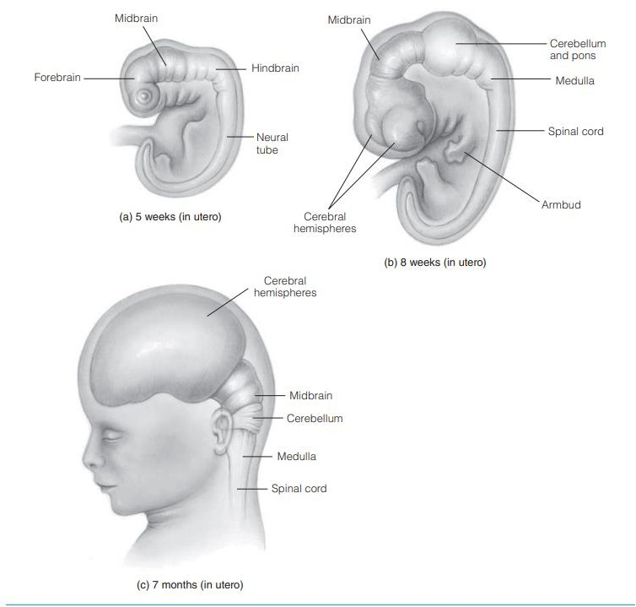

Fig: Fetal Brain Development

FETAL BRAIN DEVELOPMENT
- Over the course of embryonic and fetal development, the brain becomes more highly specialized and the locations and relative positions of the hindbrain, the midbrain, and the forebrain change from conception to term of the fully developed brain.
- Above (b) and (c) show the changing locations and relationships of the forebrain, the midbrain, and the hindbrain over the course of development of the brain. You can see how they develop, from an embryo a few weeks after conception to a fetus of seven months of age.

THE FOREBRAIN
- The forebrain is the region of the brain located toward the top and front of the brain. It comprises the cerebral cortex, the basal ganglia, the limbic system, the thalamus, and the hypothalamus (Figure 2.3).

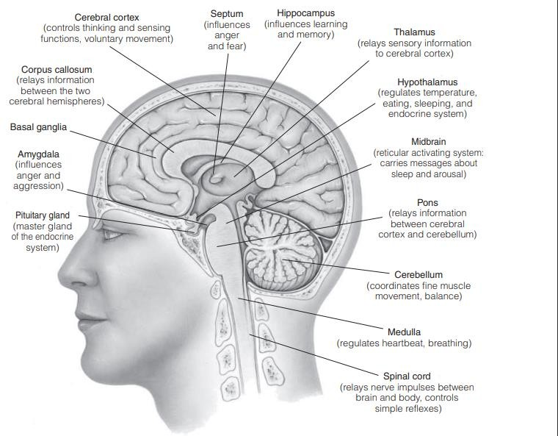
The cerebral cortex is the outer layer of the cerebral hemispheres. It plays a vital role in our thinking and other mental processes.

Fig: Structure of the brain STRUCTURES OF THE BRAIN
- The forebrain, the midbrain, and the hindbrain contain structures that perform essential functions for survival and for high-level thinking and feeling. discussion of the major structures and functions of the brain.
- The basal ganglia (singular: ganglion) are collections of neurons crucial to motor function. Dysfunction of the basal ganglia can result in motor deficits.
- These deficits include tremors, involuntary movements, changes in posture and muscle tone, and slowness of movement. Deficits are observed in Parkinson’s disease and Huntington’s disease. Both these diseases entail severe motor symptoms.

- The limbic system is important to emotion, motivation, memory, and learning. Animals such as fish and reptiles, which have relatively undeveloped limbic systems, respond to the environment almost exclusively by instinct.
- Mammals and especially humans have relatively more developed limbic systems. Our limbic system allows us to suppress instinctive responses (e.g., the impulse to strike someone who accidentally causes us pain).
- Our limbic systems help us to adapt our behaviors flexibly in response to our changing environment. The limbic system comprises three central interconnected cerebral structures: the septum, the amygdala, and the hippocampus.
- The septum is involved in anger and fear. The amygdala plays an important role in emotion as well, especially in anger and aggression.
- Stimulation of the amygdala commonly results in fear. It can be evidenced in various ways, such as through palpitations, fearful hallucinations, or frightening flashbacks in memory Damage to (lesions in) or removal of the amygdala can result in maladaptive lack of fear.
- In the case of lesions to the animal brain, the animal approaches potentially dangerous objects without hesitation or fear.
- The amygdala also has an enhancing effect for the perception of emotional stimuli. In humans, lesions to the amygdala prevent this enhancement. Additionally, persons with autism display limited activation in the amygdala.
- A well-known theory of autism suggests that the disorder involves dysfunction of the amygdala, which leads to the social impairment that is typical of persons with autism, for example, difficulties in evaluating people’s trustworthiness or recognizing emotions in faces Two other effects of lesions to the amygdala can be visual agnosia (inability to recognize objects) and hypersexuality.
- The hippocampus plays an essential role in memory formation. It gets its name from the Greek word for “seahorse,” its approximate shape. The hippocampus is essential for flexible learning and for seeing the relations among items learned as well as for spatial memory.
- The hippocampus also appears to keep track of where things are and how these things are spatially related to each other. In other words, it monitors what is where, People who have suffered damage to or removal of the hippocampus still can recall existing memories—for example, they can recognize old friends and places— but they are unable to form new memories (relative to the time of the brain damage). New information—new situations, people, and places—remain forever new.
- A disease that produces loss of memory function is Korsakoff’s syndrome. Other symptoms include apathy, paralysis of muscles controlling the eye, and tremor. This loss is believed to be associated with deterioration of the hippocampus and is caused by a lack of thiamine (Vitamin B-1) in the brain.

- The syndrome can result from excessive alcohol use, dietary deficiencies, or eating disorders. There is a renowned case of a patient known as H.M., who after brain surgery retained his memory for events that transpired before the surgery but had no memory for events after the surgery. This case is another illustration of the resulting problems with memory formation due to hippocampus damage.
- Disruption in the hippocampus appears to result in deficits in declarative memory (i.e., memory for pieces of information), but it does not result in deficits in procedural memory (i.e., memory for courses of action).
- The thalamus relays incoming sensory information through groups of neurons that project to the appropriate region in the cortex. Most of the sensory input into the brain passes through the thalamus, which is approximately in the center of the brain, at about eye level.
- To accommodate all the types of information that must be sorted out, the thalamus is divided into a number of nuclei (groups of neurons of similar function). Each nucleus receives information from specific senses. The information is then relayed to corresponding specific areas in the cerebral corte.
- x. The thalamus also helps in the control of sleep and waking. When the thalamus malfunctions, the result can be pain, tremor, amnesia, impairment of language, and disruptions in waking and in cases of schizophrenia, imaging and in vivo studies reveal abnormal changes in the thalamus.
- These abnormalities result in difficulties in filtering stimuli and focusing attention, which in turn can explain why people suffering from schizophrenia experience symptoms such as hallucinations and delusions.
- The hypothalamus regulates behavior related to species survival: fighting, feeding, fleeing, and mating. The hypothalamus also is active in regulating emotions and reactions to stress.
- It interacts with the limbic system. The small size of the hypothalamus (from Greek hypo-
, “under”; located at the base of the forebrain, beneath the thalamus) belies its importance in controlling many bodily functions (Table 2.1).
- The hypothalamus plays a role in sleep: Dysfunction and neural loss within the hypothalamus are noted in cases of narcolepsy, whereby a person falls asleep often and at unpredictable times.
- The hypothalamus also is important for the functioning of the endocrine system. It is involved in the stimulation of the pituitary glands, through which a range of hormones are produced and released. These hormones include growth hormones and oxytocin. The forebrain, midbrain, and hindbrain contain structures that perform essential functions for survival as well as for high-level thinking and feeling.

THE MIDBRAIN
- The midbrain helps to control eye movement and coordination. The midbrain is more important in nonmammals where it is the main source of control for visual and auditory information. In mammals these functions are dominated by the forebrain.
Table 2.1 lists several structures and corresponding functions of the midbrain. By far the most indispensable of these structures is the reticular activating system (RAS; also called the “reticular formation”), a network of neurons essential to the regulation of consciousness.
- The RAS also extends into the hindbrain. Both the RAS and the thalamus are essential to our having any conscious awareness of or control over our existence.
- The brainstem connects the forebrain to the spinal cord. It comprises the hypothalamus, the thalamus, the midbrain, and the hindbrain.
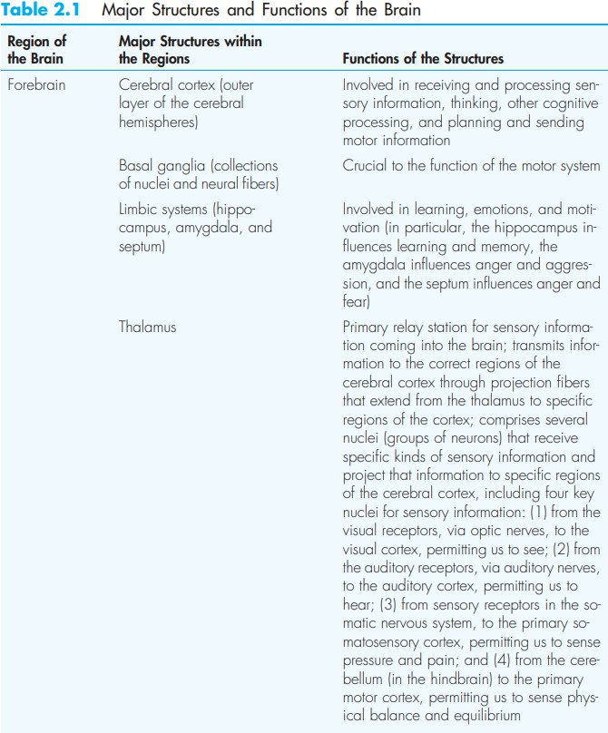
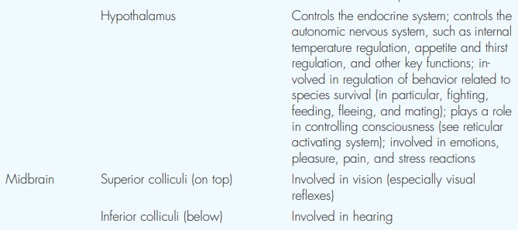

- A structure called the periaqueductal gray (PAG) is in the brainstem. This region seems to be essential for certain kinds of adaptive behaviors. Injections of small amounts of excitatory amino acids or, alternatively, electrical stimulation of this area results in any of several responses: an aggressive, confrontational response; avoidance or flight response; heightened defensive reactivity; or reduced reactivity as is experienced after a defeat, when one feels hopeless.
- Physicians make a determination of brain death based on the function of the brainstem. Specifically, a physician must determine that the brainstem has been damaged so severely that various reflexes of the head (e.g., the pupillary reflex) are absent for more than 12 hours, or the brain must show no electrical activity or cerebral circulation of blood.

THE HINDBRAIN
- The hindbrain comprises the medulla oblongata, the pons, and the cerebellum. The medulla oblongata controls heart activity and largely controls breathing, swallowing, and digestion.
- The medulla is also the place at which nerves from the right side of the body cross over to the left side of the brain and nerves from the left side of the body cross over to the right side of the brain.
- The medulla oblongata is an elongated interior structure located at the point where the spinal cord enters the skull and joins with the brain.
- The medulla oblongata, which contains part of the RAS, helps to keep us alive. The pons serves as a kind of relay station because it contains neural fibers that pass signals from one part of the brain to another. Its name derives from the Latin for “bridge,” as it serves a bridging function.
- The pons also contains a portion of the RAS and nerves serving parts of the head and face. The cerebellum (from Latin, “little brain”) controls bodily coordination, balance, and muscle tone, as well as some aspects of memory involving procedure-related movements. The prenatal development of the human brain within each individual roughly corresponds to the evolutionary development of the human brain within the species as a whole. Specifically, the hindbrain is evolutionarily the oldest and most primitive part of the brain. It also is the first part of the brain to develop prenatally.
- The midbrain is a relatively newer addition to the brain in evolutionary terms. It is the next part of the brain to develop prenatally.
- Finally, the forebrain is the most recent evolutionary addition to the brain. It is the last of the three portions of the brain to develop prenatally.
- Additionally, across the evolutionary development of our species, humans have shown an increasingly greater proportion of brain weight in relation to body weight. However, across the span of development after birth, the proportion of brain weight to body weight declines.
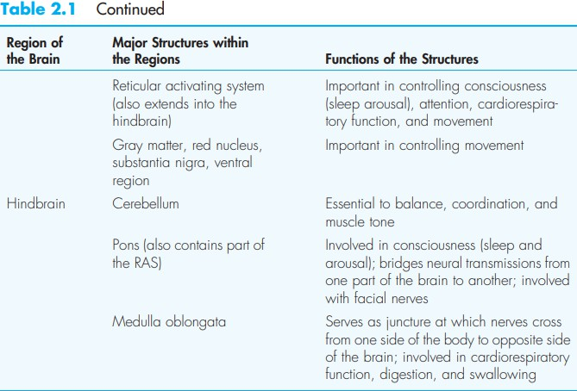
For cognitive psychologists, the most important of these evolutionary trends is the increasing neural complexity of the brain.
- The evolution of the human brain has offered us the enhanced ability to exercise voluntary control over behavior. It has also strengthened our ability to plan and to contemplate alternative courses of action. These ideas are discussed in the next section with respect to the cerebral cortex.

CEREBRAL CORTEX AND LOCALIZATION OF FUNCTION
- The cerebral cortex plays an extremely important role in human cognition. It forms a 1- to 3-millimeter layer that wraps the surface of the brain somewhat like the bark of a tree wraps around the trunk.
- In human beings, the many convolutions, or creases, of the cerebral cortex comprise three elements. Sulci (singular, sulcus) are small grooves. Fissures are large grooves and gyri (singular, gyrus) are bulges between adjacent sulci or fissures. These folds greatly increase the surface area of the cortex. If the wrinkly human cortex were smoothed out, it would take up about 2 square feet.
- The cortex comprises 80% of the human brain. The volume of the human skull has more than doubled over the past 2 million years, allowing for the expansion of the brain, and especially the cortex.
- The complexity of brain function increases with the cortical area. The human cerebral cortex enables us to think. Because of it, we can plan, coordinate thoughts and actions, perceive visual and sound patterns, and use language. Without it, we would not be human. The surface of the cerebral cortex is grayish. It is sometimes referred to as gray matter. This is because it primarily comprises the grayish neural-cell bodies that process the information that the brain receives and sends.
- In contrast, the underlying white matter of the brain’s interior comprises mostly white, myelinated axons. The cerebral cortex forms the outer layer of the two halves of the brain— the left and right cerebral hemispheres. Although the two hemispheres appear to be quite similar, they function differently.
- The left cerebral hemisphere is specialized for some kinds of activity whereas the right cerebral hemisphere is specialized for other kinds.
- For example, receptors in the skin on the right side of the body generally send information through the medulla to areas in the left hemisphere in the brain.
- The receptors on the left side generally transmit information to the right hemisphere. Similarly, the left hemisphere of the brain directs the motor responses on the right side of the body.
- The right hemisphere directs responses on the left side of the body. However, not all information transmission is contralateral—from one side to another (contra-, “opposite”; lateral, “side”).
- Some ipsilateral transmission—on the same side—occurs as well. For example, odor information from the right nostril goes primarily to the right side of the brain. About half the information from the right eye goes to the right side of the brain, the other half goes to

the left side of the brain. In addition to this general tendency for contralateral specialization, the hemispheres also communicate directly with one another.
- The corpus callosum is a dense aggregate of neural fibers connecting the two cerebral hemispheres (Witelson, Kigar, & Walter, 2003). It allows transmission of information back and forth. Once information has reached one hemisphere, the corpus callosum transfers it to the other hemisphere.
- If the corpus callosum is cut, the two cerebral hemispheres—the two halves of the brain—cannot communicate with each other (Glickstein & Berlucchi, 2008). Although some functioning, like language, is highly lateralized, most functioning—even language—depends in large part on integration of the two hemispheres of the brain.

HEMISPHERIC SPECIALIZATION

- How did psychologists find out that the two hemispheres have different responsibilities? The study of hemispheric specialization in the human brain can be traced back to Marc Dax, a country doctor in France.
- By 1836, Dax had treated more than 40 patients suffering from aphasia—loss of speech—as a result of brain damage.
- Dax noticed a relationship between the loss of speech and the side of the brain in which damage had occurred. In studying his patients’ brains after death, Dax saw that in every case there had been damage to the left hemisphere of the brain. He was not able to find even one case of speech loss resulting from damage to the right hemisphere only. In 1861, French scientist Paul Broca claimed that an autopsy revealed that an aphasic stroke patient had a lesion in the left cerebral hemisphere of the brain. By 1864, Broca was convinced that the left hemisphere of the brain is critical in speech, a view that has held up over time. The specific part of the brain that Broca identified, now called Broca’s area, contributes to speech (Figure 2.4).
- Another important early researcher, German neurologist Carl Wernicke, studied language-deficient patients who could speak but whose speech made no sense. Like Broca, he traced language ability to the left hemisphere. He studied a different precise location, now known as Wernicke’s area, which contributes to language comprehension (Figure 2.4).
- Karl Spencer Lashley, often described as the father of neuropsychology, started studying localization in 1915. He found that implantations of crudely built electrodes in apparently identical locations in the brain yielded different results. Different locations sometimes paradoxically yielded the same results.

- Subsequent researchers, using more sophisticated electrodes and measurement procedures, have found that specific locations do correlate with specific motor
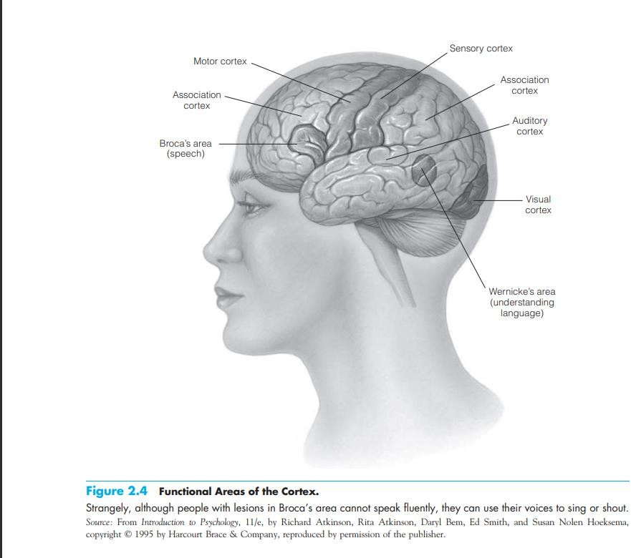
responses across many test sessions.
  - Apparently, Lashley’s research was limited by the technology available to him at the time. Despite the valuable early contributions by Broca, Wernicke, and others, the individual most responsible for modern theory and research on hemispheric specialization was Nobel Prize–winning psychologist Roger Sperry.
  - Sperry (1964) argued that each hemisphere behaves in many respects like a separate brain. In a classic experiment that supports this contention, Sperry and his colleagues severed the corpus callosum connecting the two hemispheres of a cat’s brain. They then proved that information presented visually to one cerebral hemisphere of the cat was not recognizable to the other hemisphere. Similar work on monkeys indicated the same discrete performance of each hemisphere (Sperry, 1964).
  - Some of the most interesting information about how the human brain works, and especially about the respective roles of the hemispheres, has emerged from studies of humans with epilepsy in whom the corpus callosum has been severed.

  - Surgically severing this neurological bridge prevents epileptic seizures from spreading from one hemisphere to another. This procedure thereby drastically reduces the severity of the seizures.
  - However, this procedure also results in a loss of communication between the two hemispheres. It is as if the person has two separate specialized brains processing different information and performing separate functions.

LOBES OF THE CEREBRAL HEMISPHERES
  - The four lobes, named after the bones of the skull lying directly over them (Figure 2.6), are the frontal, parietal, temporal, and occipital lobes.
  - The lobes are involved in numerous functions. Our discussion of them here describes only part of what they do.
  - The frontal lobe, toward the front of the brain, is associated with motor processing and higher thought processes, such as abstract reasoning, problem solving, planning, and judgment (Stuss & Floden, 2003). It tends to be involved when sequences of thoughts or actions are called for. It is critical in producing speech.
  - The prefrontal cortex, the region toward the front of the frontal lobe, is involved in complex motor control and tasks that require integration of information over time (Gazzaniga, Ivry, & Mangun, 2002).
  - The parietal lobe, at the upper back portion of the brain, is associated with somatosensory processing. It receives inputs from the neurons regarding touch, pain, temperature sense, and limb position when you are perceiving space and your

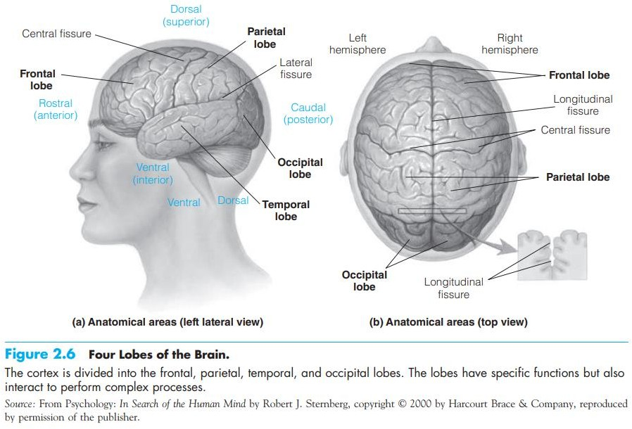

relationship to it—how you are situated relative to the space you are occupying.
  - The parietal lobe is also involved in consciousness and paying attention. If you are paying attention to what you are reading, your parietal lobe is activated. The temporal lobe, directly under your temples, is associated with auditory processing (Murray, 2003) and comprehending language.
  - It is also involved in your retention of visual memories. For example, if you are trying to keep in memory Figure 2.6, then your temporal lobe is involved.
  - The temporal lobe also matches new things you see to what you have retained in visual memory.
  - The occipital lobe is associated with visual processing (De Weerd, 2003b). The occipital lobe contains numerous visual areas, each specialized to analyze specific aspects of a scene, including color, motion, location, and form (Gazzaniga, Ivry, & Mangun, 2002).
  - When you go to pick strawberries, your occipital lobe is involved in helping you find the red strawberries in between the green leaves. Projection areas are the areas in the lobes in which sensory processing occurs.
  - These areas are referred to as projection areas because the nerves contain sensory information going to (projecting to) the thalamus. It is from here that the sensory information is communicated to the appropriate area in the relevant lobe. Similarly, the projection areas communicate motor information downward through the spinal cord to the appropriate muscles via the peripheral nervous system (PNS).

  - Now let us consider the lobes, and especially the frontal lobe in more detail. The frontal lobe, located toward the front of the head (the face), plays a role in judgment, problem solving, personality, and intentional movement. It contains the primary motor cortex, which specializes in the planning, control, and execution of movement, particularly of movement involving any kind of delayed response.
  - If your motor cortex were electrically stimulated, you would react by moving a corresponding body part. The nature of the movement would depend on where in the motor cortex your brain had been stimulated. Control of the various kinds of body movements is located contralaterally on the primary motor cortex. A similar inverse mapping occurs from top to bottom.
  - The lower extremities of the body are represented on the upper (toward the top of the head) side of the motor cortex, and the upper part of the body is represented on the lower side of the motor cortex. Information going to neighboring parts of the body also comes from neighboring parts of the motor cortex. Thus, the motor cortex can be mapped to show where and in what proportions different parts of the body are represented in the brain (Figure 2.7).
  - Maps of this kind are called “homunculi” (homunculus is Latin for “little person”) because they depict the body parts of a person mapped on the brain. The three other lobes are located farther away from the front of the head. These lobes specialize in sensory and perceptual activity. For example, in the parietal lobe, the primary somatosensory cortex receives information from the senses about pressure, texture, temperature, and pain. It is located right behind the frontal lobe’s primary motor cortex. If your somatosensory cortex were electrically stimulated, you probably would report feeling as if you had been touched.

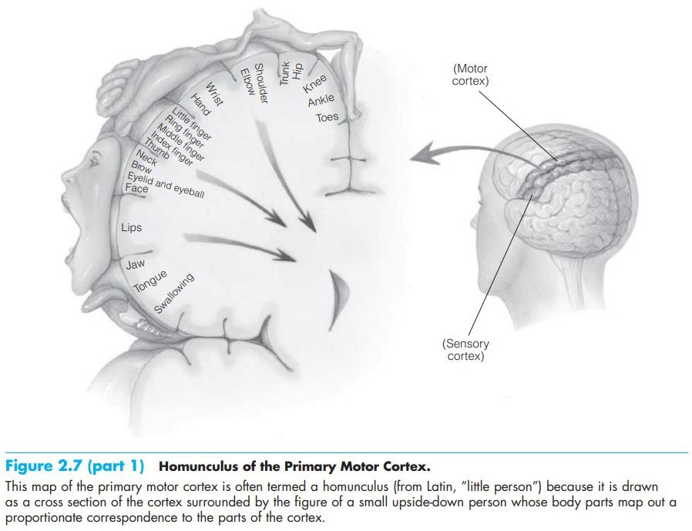

  - From looking at the homunculus (see Figure 2.7), you can see that the relationship of function to form applies in the development of the motor cortex.
  - The same holds true for the somatosensory cortex regions. The more need we have for use, sensitivity, and fine control in a particular body part, the larger the area of cortex generally devoted to that part.
  - For example, we humans are tremendously reliant on our hands and faces in our interactions with the world.
  - We show correspondingly large proportions of the cerebral cortex devoted to sensation in, and motor response by, our hands and face.
  - Conversely, we rely relatively little on our toes for both movement and information gathering. As a result, the toes represent a relatively small area on both the primary motor and somatosensory cortices.
  - The region of the cerebral cortex pertaining to hearing is located in the temporal lobe, below the parietal lobe. This lobe performs complex auditory analysis. This kind of analysis is needed in understanding human speech or listening to a symphony. The lobe also is specialized—some parts are more sensitive to sounds of higher pitch, others to sounds of lower pitch. The auditory region is primarily contralateral, although both sides of the auditory area have at least some representations from each ear.

  - If your auditory cortex were stimulated electrically, you would report having heard some sort of sound.
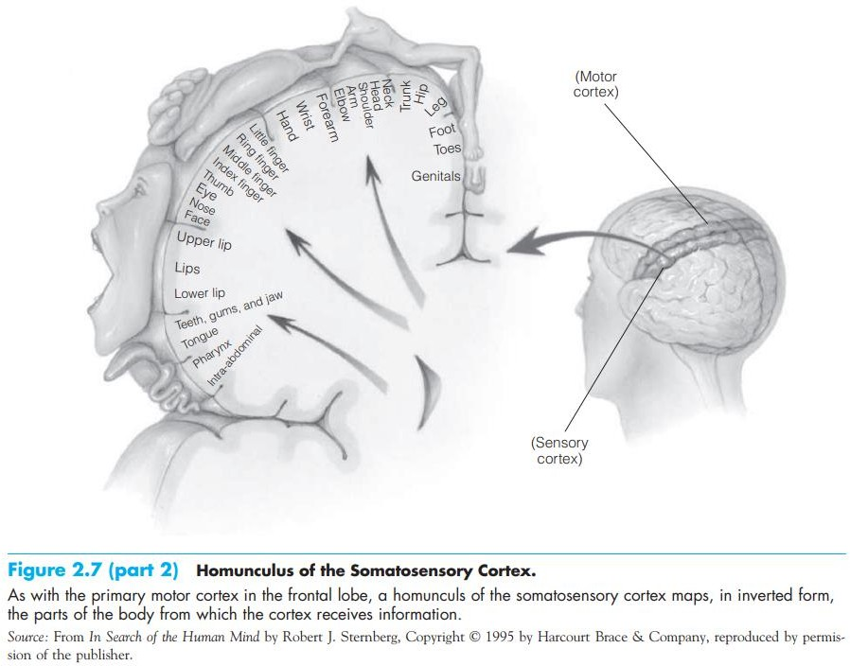

  - The visual cortex is primarily in the occipital lobe. Some neural fibers carrying visual information travel ipsilaterally from the left eye to the left cerebral hemisphere and from the right eye to the right cerebral hemisphere.
  - Other fibers cross over the optic chiasma (from Greek, “visual X” or “visual intersection”) and go contralaterally to the opposite hemisphere (Figure 2.8). In particular, neural fibers go from the left side of the visual field for each eye to the right side of the visual cortex.
  - Complementarily, the nerves from the right side of each eye’s visual field send information to the left side of the visual cortex.
  - The brain is a very complex structure, and researchers use a variety of expressions to describe which part of the brain they are speaking of. Figure 2.6 explains some other words that are frequently used to describe different brain regions. These

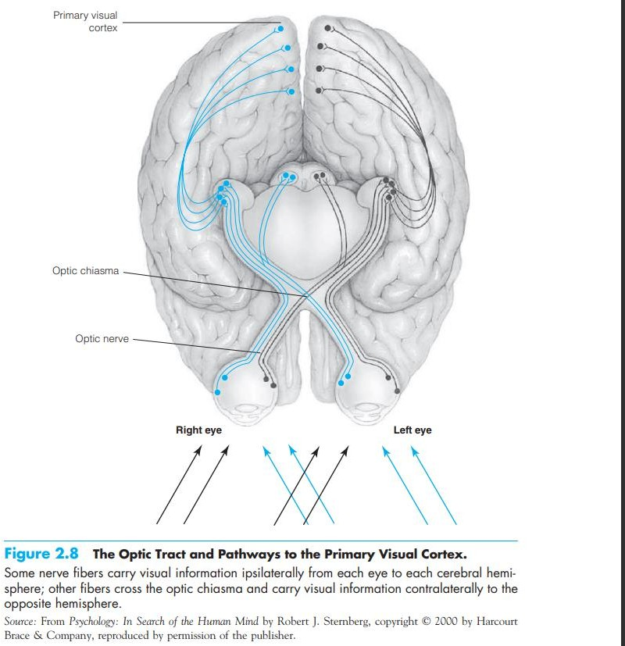

are the words rostral, ventral, caudal, and dorsal.
They are all derived from Latin words and indicate the part of the brain with respect to other body parts.
- Rostral refers to the front part of the brain (literally the “nasal region”).
- Ventral refers to the bottom surface of the body/brain (the side of the stomach).
- Caudal literally means “tail” and refers to the back part of the body/brain.
- Dorsal refers to the upside of the brain (it literally means “back,” and in animals the back is on the upside of the body).
  - The brain typically makes up only one fortieth of the weight of an adult human body. Nevertheless, it uses about one fifth of the circulating blood, one fifth of the available glucose, and one fifth of the available oxygen.
  - It is, however, the supreme organ of cognition. Understanding both its structure and function, from the neural to the cerebral levels of organization, is vital to an understanding of cognitive psychology.

NEURONAL STRUCTURE AND FUNCTION

  - To understand how the entire nervous system processes information, we need to examine the structure and function of the cells that constitute the nervous system.
  - Individual neural cells, called neurons, transmit electrical signals from one location to another in the nervous system.
  - The greatest concentration of neurons is in the neocortex of the brain. The neocortex is the part of the brain associated with complex cognition. This tissue can contain as many as 100,000 neurons per cubic millimeter.
  - The neurons tend to be arranged in the form of networks, which provide information and feedback to each other within various kinds of information processing.
  - Neurons vary in their structure, but almost all neurons have four basic parts, as illustrated in Figure 2.9. These include a soma (cell body), dendrites, an axon, and terminal buttons.
  - The soma, which contains the nucleus of the cell (the center portion that performs metabolic and reproductive functions for the cell), is responsible for the life of the neuron and connects the dendrites to the axon.
  - The many dendrites are branchlike structures that receive information from other neurons, and the soma integrates the information. Learning is associated with the formation of new neuronal connections.
  - Hence, it occurs in conjunction with increased complexity or ramification in the branching structure of dendrites in the brain. The single axon is a long, thin tube that extends (and sometimes splits) from the soma and responds to the information, when appropriate, by transmitting an electrochemical signal, which travels to the terminus (end), where the signal can be transmitted to other neurons.
  - Axons are of two basic, roughly equally occurring kinds, distinguished by the presence or absence of myelin. Myelin is a white, fatty substance that surrounds some of the axons of the nervous system, which accounts for some of the whiteness of the white matter of the brain. Some axons are myelinated (in that they are surrounded by a myelin sheath).

  - This sheath, which insulates and protects longer axons from electrical interference by other neurons in the area, also speeds up the
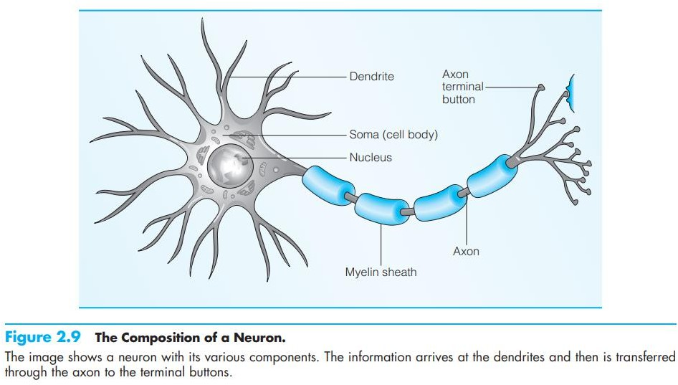

conduction of information.
  - In fact, transmission in myelinated axons can reach 100 meters per second (equal to about 224 miles per hour). Moreover, myelin is not distributed continuously along the axon. It is distributed in segments broken up by nodes of Ranvier.
  - Nodes of Ranvier are small gaps in the myelin coating along the axon, which serve to increase conduction speed even more by helping to create electrical signals, also called action potentials, which are then conducted down the axon.
  - The degeneration of myelin sheaths along axons in certain nerves is associated with multiple sclerosis, an autoimmune disease. It results in impairments of coordination and balance. In severe cases this disease is fatal.
  - The second kind of axon lacks the myelin coat altogether. Typically, these unmyelinated axons are smaller and shorter (as well as slower) than the myelinated axons.
  - As a result, they do not need the increased conduction velocity myelin provides for longer axons (Giuliodori & DiCarlo, 2004).
  - The terminal buttons are small knobs found at the ends of the branches of an axon that do not directly touch the dendrites of the next neuron. Rather, there is a very small gap, the synapse.
  - The synapse serves as a juncture between the terminal buttons of one or more neurons and the dendrites (or sometimes the soma) of one or more other neurons (Carlson, 2006).
  - Synapses are important in cognition. Rats show increases in both the size and the number of synapses in the brain as a result of learning (Federmeier, Kleim & Greenough,
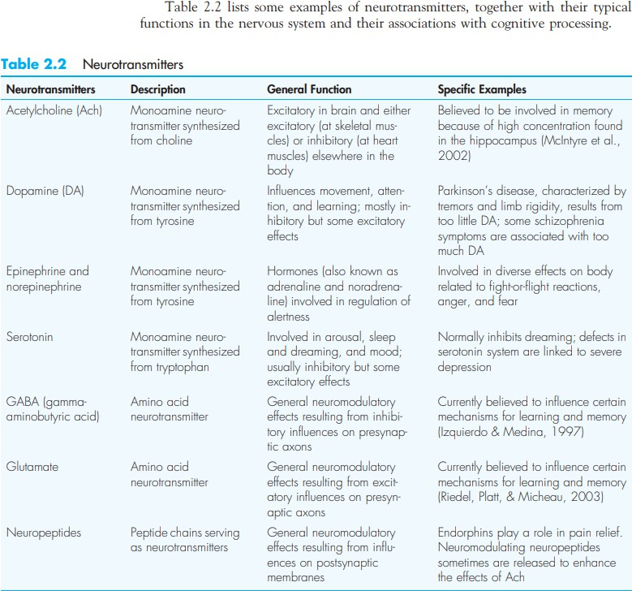’

BRAIN IMAGING ELEMENTS
Studying Live Nonhuman Animals

- Scientists also want to understand the physiological processes and functions of the living brain. To study the changing activity of the living brain, scientists must use in vivo research. Many early in vivo techniques were performed exclusively on animals.
- To obtain single-cell recordings, researchers insert a very thin electrode next to a single neuron in the brain of an animal (usually a monkey or a cat). They then record the changes in electrical activity that occur in the cell when the animal is exposed to a stimulus.
- In this way, scientists can measure the effects of certain kinds of stimuli, such as visually presented lines, on the activity of individual neurons. Neurons fire constantly, even if no stimuli are present, so the task of the researcher is to find stimuli that produce a consistent change in the activity of the neuron. This technique can be used only in laboratory animals, not in humans, because no safe way has yet been devised to perform such recordings in humans.
- A second group of animal studies includes selective lesioning—surgically removing or damaging part of the brain—to observe resulting functional deficits (Al’bertin, Mulder, & Wiener, 2003; Mohammed, Jonsson, & Archer, 1986).
- In recent years, researchers have found neurochemical ways to induce lesions in animals’ brains by administering drugs that destroy only cells that use a particular neurotransmitter. Some drugs’ effects are reversible, so that conductivity in the brain is disrupted only for a limited amount of time (Gazzaniga, Ivry, & Mangun, 2009).
- A third way of doing research with animals is by employing genetic knockout procedures. By using genetic manipulations, animals can be created that lack certain kinds of cells or receptors in the brain. Comparisons with normal animals then indicate what the function of the missing receptors or cells may be.

Studying Live Humans
Obviously, many of the techniques used to study live animals cannot be used on human participants. Generalizations to humans based on these studies are therefore somewhat limited. However, an array of less invasive imaging techniques for use with humans has been developed. These techniques—electrical recordings, static imaging, and metabolic imaging—are described in this section.

Electrical Recordings
The transmission of signals in the brain occurs through electrical potentials. When recorded, this activity appears as waves of various widths (frequencies) and heights (intensities).

- Electroencephalograms (EEGs) are recordings of the electrical frequencies and intensities of the living brain, typically recorded over relatively long periods (Picton & Mazaheri, 2003). Through EEGs, it is possible to study brainwave activity indicative of changing mental states such as deep sleep or dreaming. To obtain EEG recordings, electrodes are placed at various points along the surface of the scalp. The electrical activity of underlying brain areas is then recorded. Therefore, the information is not localized to specific cells. However, the EEG is very sensitive to changes over time.
- For example, EEG recordings taken during sleep reveal changing patterns of electrical activity involving the whole brain. Different patterns emerge during dreaming versus deep sleep.
- EEGs are also used as a tool in the diagnosis of epilepsy because they can indicate whether seizures appear in both sides of the brain at the same time, or whether they originate in one part of the brain and then spreadERP can be used to examine developmental changes in cognitive abilities. These experiments provide a more complete understanding of the relationship between brain and cognitive development (Taylor & Baldeweg, 2002).
- The high degree of temporal resolution afforded by ERPs can be used to complement other techniques. For example, ERPs and positron emission tomography (PET) were used to pinpoint areas involved in word association (Posner & Raichle, 1994). Using ERPs, the investigators found that participants showed increased activity in certain parts of the brain (left lateral frontal cortex, left posterior cortex, and right insular cortex) when they made rapid associations to given words. Another study showed that decreases in electrical potentials are twice as great for tones that are attended to as for tones that are ignored (see Phelps, 1999). As with any technique, EEGs and ERPs provide only a glimpse of brain activity. They are most helpful when used in conjunction with other techniques to identify particular brain areas involved in cognition.

Static Imaging Techniques

Psychologists use still images to reveal the structures of the brain (see Figure 2.10 and Table 2.3). The techniques include angiograms, computed tomography (CT) scans, and magnetic resonance imaging scans (MRI). The X-ray–based techniques (angiogram and CT scan) allow for the observation of large abnormalities of the brain, such as damage resulting from strokes or tumors. However, they are limited

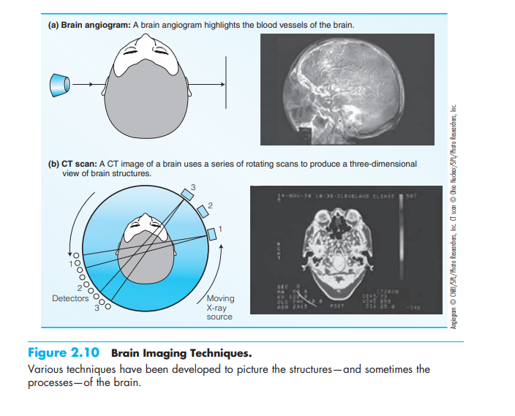
in their resolution and cannot provide much information about smaller lesions and aberrations. Computed tomography (CT or CAT). Unlike conventional X-ray methods that only allow a two-dimensional view of an object, a CT scan consists of several X-ray images of the brain taken from different vantage points that, when combined, result in a three-dimensional image. The aim of an angiography is not to look at the structures in the brain, but rather to examine the blood flow. When the brain is active, it needs energy, which is transported to the brain in the form of oxygen and glucose by means of the blood. In angiography, a dye is injected into an artery that leads to the brain, and then an X-ray image is taken. The image shows the circulatory system, and it is possible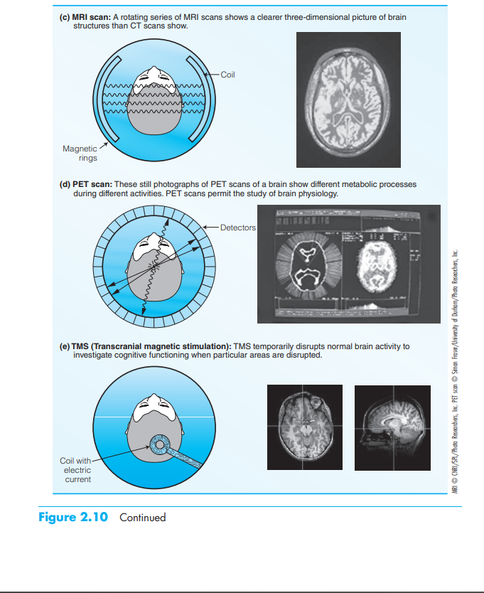

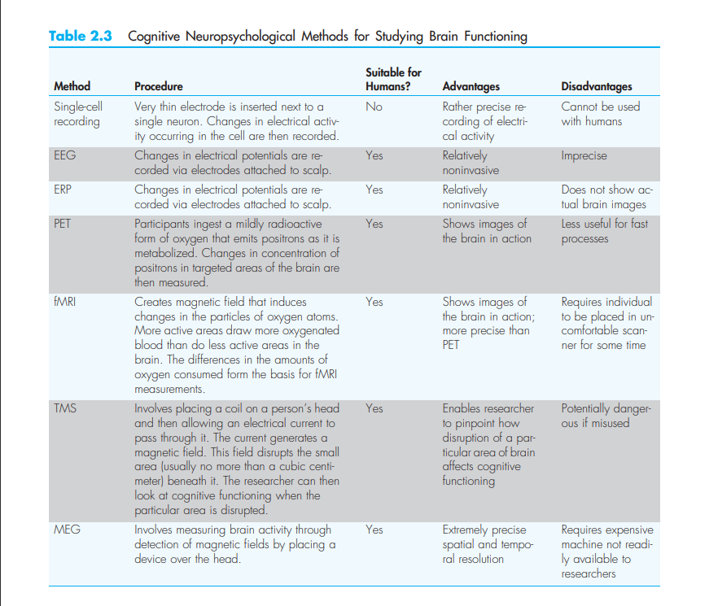

to detect strokes (disruption of the blood flow often caused by the blockage of the arteries through a foreign substance) or aneurysms (abnormal ballooning of an artery), or arteriosclerosis (a hardening of arteries that makes them inflexible and narrow). The magnetic resonance imaging (MRI) scan is of great interest to cognitive psychologists (Figure 2.11). The MRI reveals high-resolution images of the structure of the living brain by computing and analyzing magnetic changes in the energy of the orbits of nuclear particles in the molecules of the body. There are two kinds of

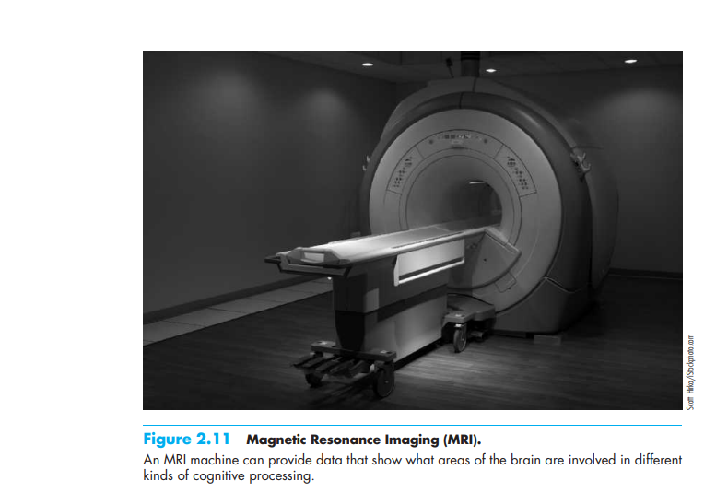

- MRIs—structural MRIs and functional MRIs. Structural MRIs provide images of the brain’s size and shape whereas functional MRIs visualize the parts of the brain that are activated when a person is engaged in a particular task. MRIs allow for a much clearer picture of the brain than CT scans. A strong magnetic field is passed through the brain of a patient. A scanner detects various patterns of electromagnetic changes in the atoms of the brain. These molecular changes are analyzed by a computer to produce a three-dimensional picture of the brain. This picture includes detailed information about brain structures.
- For example, MRI has been used to show that musicians who play string instruments such as the violin or the cello tend to have an expansion of the brain in an area of the right hemisphere that controls left-hand movement (because control of hands is contralateral, with the right side of the brain controlling the left hand, and vice versa; Münte, Altenmüller, & Jäncke, 2002). We tend to view the brain as controlling what we can do. This study is a good example of how what we do—our experience—can affect the development of the brain. MRI also facilitates the detection of lesions, such as lesions associated with particular disorders of language use, but does not provide much information about physiological processes. However, the two techniques discussed in the following section do provide such information.

Metabolic Imaging
- Metabolic imaging techniques rely on changes that take place within the brain as a result of increased consumption of glucose and oxygen in active areas of the brain. The basic idea is that active areas in the brain consume more glucose and oxygen than do inactive areas during some tasks.
- An area specifically required by one task ought to be more active during that task than during more generalized processing and thus should require more glucose and oxygen. Scientists attempt to pinpoint specialized areas for a task by using the subtraction method.
- This method uses two different measurements: one that was taken while the subject was involved in a more general or control activity, and one that was taken when the subject was engaged in the task of interest. The difference between these two measurements equals the additional activation recorded while the subject is engaged in the target task as opposed to the control task. The subtraction method thus involves subtracting activity during the control task from activity during the task of interest.
The resulting difference in activity is analyzed statistically. This analysis determines which areas are responsible for performance of a particular task above and beyond the more general activity.

Language & Linguistic Knowledge: Background and details of Syntax & Semantics, Understanding of Generative Linguistic.
INTRODUCTION
- All normal human children acquire at least one natural language in the process of their development. The successful completion of this task seems largely independent of race, religion, culture, general intelligence, or location.
- In fact, many would contend that the natural ability to acquire a language is the chief defining criterion for what it means to be human. Furthermore, it is easy to see why the process of language acquisition should draw such considerable attention from cognitive scientists.
- The information processing system that develops in the child to subserve the language function can profitably be investigated from each point of view represented in the field. For example, linguists explore the representation of the knowledge that the child comes to represent, psychologists and researchers in artificial intelligence (AI) study the processes involved in the acquisition and deployment of linguistic knowledge, and philosophers investigate the implications of rival learning theories, for instance, with regard to the epistemological status of linguistic knowledge.
- Finally, although we will not explore such work here, neuroscientists provide insight into the nature of language acquisition by exploring the emerging neurological and brain mechanisms that underlie language development. For these reasons, among others, the study of language acquisition is at the confluence of the sovereign disciplines in cognitive science. It may at first seem surprising that a process as omnipresent as language acquisition should be the focus of so much academic attention.
- Indeed, prior to studying this field, many casually assume that there is little difficulty in accounting for how children learn language—children are simply trained to speak by parents and others in their linguistic community. After all, since language is rule-governed, it is not unreasonable to assume that parents simply inculcate the appropriate rule systems in their children.
- On this view, children rather passively learn language because they are taught. Very quickly, however, our confidence in this sort of analysis is shaken. Although linguistic knowledge is representable in the form of rule systems, the grammars that linguists write about are hypotheses about unconscious rules.
- We emphasize the hypothetical nature of these grammars to make the point that grammars, viewed from a research perspective, are scientific constructs. Therefore, it is presumptuous to assume that parents can fully articulate to their children linguistic rule systems that, in part, resist our best efforts at scientific inquiry.
- Furthermore, parents do not generally have access to the relevant rules of their language. That is because our linguistic knowledge is unconscious. Although we may, from time to time, have cause to reflect on our language use, we simply do not have reliable access to the systematic body of knowledge that underlies our linguistic ability. Therefore, since parents cannot teach what they do not (know they) know, language acquisition must proceed somewhat differently than we might have thought.
- The position that virtually all theorists have accepted is that parents generally teach children language only in a very indirect manner. Of course, parents contribute richly to the child's linguistic environment. They illustrate the language, in effect, modeling the end-state that the child is destined to attain.
- The information-processing theory we are developing views the situation roughly as follows. The child is initially faced with a sea of linguistic data. From these data the child must abstract the pattern of the language being learned.
- The child's situation is in certain regards quite similar to that in which linguists find themselves. Working from data that include utterances drawn from a language, linguists attempt to write grammars that define the well-formed syntactic, semantic, and phonological structures of that language.
- Children are also faced with specimens of a language, and their task, too, is to discover the operative rule systems. For this reason, the child has been metaphorically described as a "little linguist" (Valian, Winzemer, and Errlich 1981) to emphasize the fact that language learners must process the linguistic information that surrounds them and test hypotheses about the nature of their language against these data.
- It is active in the sense that the linguistic knowledge that the child must learn is not simply presented in the form of a grammar that can be internalized directly; instead, linguistic data are presented, and the grammar must be actively (but not consciously) deduced. As we have seen, the process of deducing a grammar from linguistic data is an imposing intellectual task when undertaken by adult scientists.
- In fact, if we compare the progress made in linguistic theory in the last thirty¬five years to that made by any randomly selected language-learning child, we discover that in learning a native language, there is a sense in which the child accomplishes by puberty what linguists have not yet managed to do in several decades: extrapolate a complete grammar from linguistic data. This circumstance raises a multitude of questions about the language-learning abilities of normal children.
- We must wonder what capacities children have by virtue of which they learn language with such facility. Our explanation for how children learn language will come from studying language, observing and experimenting with children, and designing theories of language acquisition that explain the growth of linguistic knowledge. After looking at a thumbnail sketch of the course of language development, we will turn to recent work in cognitive science that tries to explain the nature of language acquisition.

MILESTONES IN ACQUISITION

Babbling
- Most of our knowledge about the earliest stages of language development comes from observation and diary studies and some important experimental research. It is useful to divide early acquisition into two stages: prelinguistic and linguistic.
- In the prelinguistic stages the child's language capacity matures without any clearly identifiable linguistic production. Still, at a very early age—in fact, before birth—children begin to develop in ways that bring them closer to language.
- The child's first vocalization is usually the birth cry, but well before this, even in utero, there is considerable growth of structure and function that will come to subserve language (for example, in the auditory system and the central nervous system). There is even some evidence that unborn fetuses are capable of remembering messages heard before birth (see Reich 1986).
- Very soon after birth, children can discriminate sounds on the basis of change in voicing, place of articulation, stress, and intonation. Putting aside the biological changes facilitating language development that take place in the very early months of the child's life (Carmichael 1964) and the earliest cries and vocalizations, it is the babbling of young children at approximately six months of age that signals the onset of linguistic production.
- Emerging after the cooing and gurgling sounds that precede it, the babbling period features many sounds occurring in the languages of the world, although not always in the language the child is destined to learn.
- This stage seems prelinguistic by virtue of the fact that the sounds produced during the babbling phase appear not to be intended by the child to convey linguistic meaning. But since babbling is marked by a variety of sounds that are included in the child's target language, some researchers (for instance, Allport 1924) contend that babbling signals the beginning of the child's communicative linguistic ability. They point out, for example, that the sounds of the babbling stage provide the repertoire out of which children identify the phonemes of their language.
- However, McNeill (1970), citing work by Bever (1961), points out that the order in which sounds emerge during babbling is generally opposite to that in which sounds emerge in the child's first words.

The First Words
- The first indisputably linguistic stage of language acquisition seems to be the one-word stage. At this stage, which typically occurs within a few months of the child’s first birthday, children produce their first words.
- By investigating the principles of information processing that are at work in the course of language acquisition, researchers hope to explain these discrepancies between what the child hears and what the child say According to one theory of phonological development due to Jakobson (1968), "It is the frequency in the languages of the world, and not how frequent the phoneme is in the particular language the child hears, that is important.
- Clearly, children are not aware of universal linguistic generalizations, and even if they were, it is not clear why this would facilitate the acquisition of the more widely distributed features of language.
- In particular, it is important to clarify just what sort of knowledge the child must master during the process of language acquisition. Frege's distinction between sense and reference is relevant; we can explore how children form and organize meanings and how they learn to refer In fact, initially, pairings of words with referents may not involve reference at all.
- Children's early uses of words may instead involve a looser type of association. At this stage, although children can sometimes successfully match words with an appropriate object, they may be able to do so only in the context of a ritual or game.
- For example, although children may be able to name an object in a picture book, they may fail to correctly label an actual occurrence of the same object. As children develop fully referential uses of words, they become able to name objects in the absence of prompting or a stereotypical context, to reason about objects that are referred to but absent, and later to retrieve requested objects by themselves from a remote location.
- Clark's account of semantic acquisition crucially involves the assumption that children learn word meanings by bundling together semantic features that collectively constitute the concept expressed by a term.
- In effect, this hypothesis about lexical development sees the child amassing a database whose primitives, semantic features, are associated as a group with a single node, in turn associated with a lexical item.
- If a child mistakenly associates too many or too few features with a given term, the resulting concept will be overly restrictive or overly general, respectively, leading to over- and underextension in reference. Although the details of this explanation are controversial (Carey 1978), the idea that children construct concepts out of some kind of conceptual primitives is less so.
- As in the case of phonological acquisition, then, there is evidence that children acquire abstract representations on their way to learning their language, even at the very earliest stages of acquisition. Thus far in our investigation of the one-word stage we have concentrated on what children understand about the meaning and pronunciation of their first words. Before leaving this stage, however, we should briefly consider what is known about how children first identify words as the basic currency of language.
- The central question to ask in this regard is how children determine what the words of their language are. In particular, how are children able to individuate the words in the speech stream to which they are exposed? Since typically there are no pauses between sounds in a word or between words in a phrase in normal articulation, children must generally rely on some cue other than intervening periods of silence to identify the parts of the speech stream.
- This requires parsing a continuous speech signal into constituents (for example, phonemes, morphemes, words, and phrases) that are not obviously physically demarcated.
- How, then, does the child efficiently individuate words in the flow of language? Gleitman et al. (1988) argue that word identification is initially bootstrapped by the child's attention to the feature of linguistic stress. That is, the parts of the speech stream that bear stress are salient for the child. This may explain why stressed syllables are the first to be pronounced (for example, raff for giraffe); why, when words have both stressed and unstressed forms (for example, not/n't), the former are learned first (Bellugi 1967); and why words that generally lack stress (for instance, function words in English) are omitted from early speech (but see below for another explanation).
- On this view, children at the one¬word stage identify stressed syllables as their first "words," incorporating unstressed material at a later stage of development. Thus, even though our first assumptions about language acquisition viewed children as simply acquiring sounds and meanings, our cursory investigation of the child's first words indicates that the strategies children use to extract linguistic patterns are quite sophisticated.
- Furthermore, even the linguistic knowledge acquired by the average one¬year-old takes the form of a rich system of rules and representations that must be deduced from the child's experience with a linguistic community.
- Early linguistic development is marked by considerable progress, as well as by mistakes and mismatches between the child's and the adult's grammar. Indeed, it is often precisely the child's linguistic errors that provide the deepest insights into the nature of the acquisition process and the cognitive mechanisms of the child's emerging information¬processing system.

The Emergence of Syntax
- At the one-word stage of development we restricted our discussion to the semantic, phonetic, and phonological aspects of language development. As far as the child's early linguistic production is concerned, there is little evidence at this stage of mastery of the syntactic rule system.
- Most lexical items are uninflected, there do not appear to be distinct lexical categories, and answers to wh-questions are not reliably categorically correct (Radford 1990). As the child's utterances expand in length to two words, it begins to be possible to examine syntactic development, at least in a rudimentary fashion.
- Examples of two¬word utterances might include mommy sock, allgone sticky, more cookie, and fix shoe. Just as in the one-word stage, the pronunciations and intended meanings of the spoken words may deviate from the adult model.
- For now, however, let us restrict our attention to syntactic structure. A popular early hypothesis concerning the pattern of these two-word utterances (Braine 1963) contended that children organized vocabulary words into two lexical classes called pivot and open.
- It was claimed that children's two-word utterances were composed of either two open¬class words or one open-class word and one pivot¬class word, in either order. One-word utterances would be selected solely from the open class, with the result that pivot-pivot sequences and pivot singletons were supposed not to occur.
- The assignment of words to one class or the other would need to be discovered for each individual child by looking carefully at production data. If, for example, a child produced ball on one occasion and hit on another, each word would be assigned to the open class for the child in question, since only pivot words were argued to appear alone in one-word utterances.
- This theory would therefore predict that ball hit and hit ball should be possible utterances for this child.
- Conversely, any word used by the child that failed to appear alone in a single-word utterance would be assigned to the pivot class, and the theory would predict that no two such words would be strung together in a two¬word utterance. As researchers looked more closely at the utterances produced by children at the two-word stage, a number of counterexamples to the pivot-open hypothesis emerged.
- Nevertheless, even at this early stage of development the child seems to be following a grammar. The speech of twenty¬eight¬month-old Adam, a child studied by Roger Brown and his colleagues (Brown and Fraser 1963), was described by McNeill (1970) by the following three phrase structure rules:

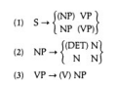

- Sample utterances generated by this grammar include doggie eat, that flower, Adam write, and put on. As McNeill pointed out, it is unsurprising that the child's first grammar should be so simple.
- Nevertheless, despite the tiny number of rules, the concepts of optionality and order already seem to be in place, indicating that certain of the key principles of the developing linguistic system have emerged at this early stage of development. As combinations of words emerge, the child begins to systematically establish relationships between them.
- The earliest such relations appear to include those of modifier-modified and agent¬action. In the first case, taking more cookie as an example, the child must come to grasp that more specifies an amount of cookie and must not be interpreted as the subject of cookie, perhaps meaning that more stands for something that is a (kind of) cookie.
- The example doggie eat may well involve an interpretation in which the dog is the subject of eat and carries out the associated action. The point is that the order and juxtaposition of terms do not predict the nature of the semantic relationship between those terms in any simple manner, even in a language like English that is quite sensitive to word order in sentence construction. These semantic relations (sometimes called thematic relations) develop over time, apparently beginning at the two-word stage.
- Some researchers, such as Bloom (1970) and Bowerman (1973), have proposed that thematic relations constitute the first important structural relations that the child uses to construct multiword utterances, suggesting that the child's first grammar may be best described in thematic terms.
- Such a system might analyze sentences in terms of categories like agent and action instead of the syntactic categories Noun Phrase and Verb Phrase.
- Against this, however, Radford (1990) argues that the increasing use of inflections and the growing ability to reply to wh-questions with answers in the proper syntactic category suggest that children have begun to understand parts of speech and to employ an essentially syntactic organization of the grammar, often before their second birthday.
- Radford also provides evidence that children at this stage organize sentences in terms of hierarchical structure, as, for example, in the case of rule (2), which analyzes a DET N sequence as a single constituent.
- Another suggestion, made by Berwick and Weinberg (1983), is that children's early grammars are based on the assumption that each syntactic structure is correlated with exactly one thematic structure. Thus, at these early stages of development every NP-VP sequence would be interpreted by an agent-action relationship, and similarly for other syntactic sequences.
- However, there is some evidence that by the later portion of the two-word stage children are capable of associating a single syntactic structure with more than one thematic structure, and of associating a single thematic structure with more than one syntactic structure (Radford 1990).
- This suggests that by this stage children have developed abstract syntactic representations that they associate with thematic representations. In other words, children at the late two¬word stage seem to have already developed an autonomous level of syntactic representation that mediates between sound and meaning, just as it does in adult grammars.
- There are, of course, a number of ways in which the linguistic systems of children at this stage of development differ from the adult system.
- In addition to waging continued struggles with pronunciation and meaning, children deviate in quite interesting ways from the syntactic pattern of the adult speech community.
- Obviously, they produce much briefer sentences; moreover, most of their utterances are innovative in that they are not imitations of adult speech. Some of the examples of twoword utterances we have discussed—such as allgone sticky—clearly suggest that creative speech is already present.
- Why it should be that children pass through this stage of development remains poorly understood. It may turn out that extragrammatical factors such as limitations of memory or attention span account for restricted production. What is clear, however, is that children do indeed go through a procedure of grammar construction that is in evidence at the earliest stages of multiword utterances.

Beyond the Two-Word Stage
- Although the one¬ and two-word stages of language development do not have precise beginnings and endings, they are plateaus reliably found in children's patterns of language acquisition.
- After the two-word stage, however, there do not seem to be easily identifiable stages corresponding in any simple way to the number of words per utterance. Moreover, soon after their second birthday, children learning inflected languages such as English begin to tackle the system of prefixes and suffixes that in part compose the morphology of their language, and this precipitates the need for a more fine¬grained measure of linguistic development.
- The calculation of the mean length of utterance (MLU) in terms of the number of morphemes per utterance allows us to take the development of inflectional systems into consideration.
- As the child's MLU shoots upward, the complexity of the grammar that generates each successive body of new data itself becomes more complicated both in the number and in the type of rules involved.
- Although Adam's grammar at twenty-eight months comprised only three phrase structure rules, at thirty-six months the same child's verbal output was analyzed by a grammar that Brown, Cazden, and Bellugi (1970) judged to include over a dozen phrase structure rules as well as several transformational rules, including a transformation for forming questions.
- The utterances produced by two¬ and three¬year-olds are, again, often ill formed by adult standards. The following examples of the speech of two¬ to three¬year-olds with MLU in the vicinity of five morphemes per utterance are typical (the utterances are taken from various sources): (4) Count a buttons. It fell in sand box. The monster's coming. Mommy try it. What that? No sit here. Where those dogs goed? Put truck window. In contrast to the holophrastic speech of children at earlier developmental stages, the speech of children at this level of development has been described as telegraphic speech. The final example in (4) clearly illustrates what is meant by this label in that the child has omitted the small function words, in this case the determiner and the preposition, much as someone with an eye toward economy would phrase a telegram.
- Radford (1990) suggests that telegraphic speech generally arises because of the basic organization of children's early grammars, which fails to provide syntactic representation for functional categories.
- The syntactic form of early questions is also quite intriguing. Both of the interrogatives in (4) reveal some difficulty with the process of auxiliary inversion, which places a verbal element (in these cases, is and did) to the left of subject position in wh¬questions. In the case of What that? the verb is is omitted from the sentence, a typical feature of children's speech at this stage.
- The second question exhibits several departures from adult English. In addition to the previously noted omission of did, the tense of the sentence is displayed on the main verb as goed. As we will now see, the investigation of such illegal past-tense forms can reveal quite a bit about how the child organizes linguistic knowledge, even at this relatively early stage of development.

Irregularity And Linguistic Representation
- It is quite common to find that children pass through a number of stages before they master correct irregular past-tense forms, such as the alternation between go and went. Kuczaj (1978) proposes that this developmental sequence begins with children occasionally using the correct past-tense forms of irregulars (for example, went), with the incorrect forms rarely in evidence. Next they begin to introduce forms such as goed, with some uses of the correct forms still persisting.
- In a third stage children add a second type of error that involves applying the regular past¬tense rule to the irregular past-tense form (for example, wented), although again they continue to use the earlier forms (went and goed).
- Finally, the incorrect forms drop out of use, resulting in the reliable use of the correct irregular forms, although this process takes years to work to completion.
- However, they were able to confirm that children's use of the incorrect forms continues at a constant rate for several years and that the introduction of these forms follows a period in which children use the correct forms (a phenomenon they call U-shaped development). It is of considerable interest to establish why children take these backward steps during language acquisition. One explanation suggests that children at first simply imitate the correct past-tense form, went. At a later point, after they have acquired the general rule for past-tense formation, they creatively apply it to the base form go, even though they have never actually heard the form goed in their linguistic environment.
- At the next stage children appear to move closer to the idea that all pasttense forms should have overt past morphology (-ed), yielding a second class of incorrect forms. In time children must learn that the irregular past tense went is the only appropriate form, although many children resist this conclusion for some time.
- In this case, then, the emergence of a linguistic rule actually leads the child away from identifying the correct linguistic forms. Of course, in regular cases this same rule constitutes a powerful learning device that allows the child to incorporate a large number of correct forms as a single class of phenomena rather than on a case-bycase basis.
- Finally, the persistence of incorrect forms over time provides intriguing evidence that reveals the extent to which the acquisition of linguistic knowledge is shaped by linguistic rule systems. Although this emphasis on rule systems as explanations for cognitive phenomena is a hallmark of most classical approaches to cognitive science, in the connectionist paradigm it is assumed that the fundamental unit of processing and representation is an element that has more in common with a simple (if abstract) neuron.
- On this view, knowledge—whether information about the world, memory, or the representation of linguistic generalization—resides in a complex of connectivity that arises in the mind as the result of the interaction of myriad very simple processing units.
- In most connectionist theories, knowledge does not—indeed, cannot—take the form of abstract rules and higher-order structures that are typical of contemporary linguistic theories as well as of the accounts of language acquisition that draw inspiration from such theories.
- Notions like transformational rule or phrase structure tree, for example, can have no independent status in a connectionist model, since whatever knowledge they embody, like everything else in the mind, is ultimately built out of simple, relatively homogeneous processing units that are not uniquely dedicated to special tasks like the representation of linguistic knowledge. On the contrary, for the connectionist, there are no ''executive or other overseer" units (Rumelhart and McClelland 1986a) that regulate cognitive systems. Connectionist models have been developed in a number of domains of linguistic representation, though as yet there are few that are capable of handling the kinds of problems we have been discussing.
- However, one of the most interesting and controversial connectionist models is Rumelhart and McClelland's (1986b) account of the child's capacity to learn and use the English past-tense system, an analysis that bears on the discussion of irregular past tense forms that we have just developed.
- We assume that the speaker has learned a set of phonological rules of essentially the following form: (5) Past¬tense formation If a verb stem ends in a voiced segment (for example, hug), add the pasttense ending /d/ to the end of the stem; If a verb stem ends in a voiceless segment (for example, lick), add /t/ to the end of the stem; Unless the verb stem ends in a coronal stop /t/ or /d/ (for example, want or seed), in which case, add / / regardless of the voicing of the final segment.
- In addition to these rules, about 150 verbs in English including go, eat, hit, see, and leave are unusual in that they undergo one of a set of special past-tense changes. These might involve an internal vowel change, as in ring rang or leave left, or, in the case of go went, a completely irregular alternation.
- At the heart of our explanation of the developmental sequence for regular and irregular past-tense forms is the multilayered set of interrelated rules and representations crucially including (1) a lexicon of underlying representations,
(2) a set of morphological principles for constructing complex words from basic underlying representations,
(3) a set of phonological rules that determine the phonetic properties of those representations, and
(4) a phonetic output consisting of direct instructions for pronouncing words. In Rumelhart and McClelland's (1986b) model (henceforth RM), there are no phonological rules like those in (5), no morphological constructs such as word or verb stem, and no structural/positional notions such as end of stem or word boundary.
- The RM model's internal knowledge state is a connectionist network of weighted nodes that directly represents the probabilities that certain types of verbs will be associated with particular inflected (past-tense) phonetic forms. This is accomplished by training the model—providing it with sufficient examples of actual pairs of uninflected and past-tense forms.
- The only relevant mechanism in the model is a pattern associator with two layers of nodes, the first of which represents uninflected verbs as input, and the second of which produces inflected past¬tense verbs as output. On the whole, the RM model does a remarkable job of producing appropriate past-tense outputs without ever having been trained on or directly representing a rule.
- Furthermore, the model, if ultimately successful, would provide an account of linguistic knowledge in which the very notion of an explicit rule system was unnecessary. If connectionist models of this sort were able to accomplish this goal for the full range of linguistic generalizations that linguists can discern, much of the debate around the nature of linguistic representation might be resolved.
- In particular, there would be no grounds for assuming a special role for grammar, independent of other systems of knowledge; in effect, there would be no grammar. This is just as the (radical) connectionists would have it, since their view of cognition is that it is uniformly based on a nonmodular, homogeneous learning and representational system.
- The RM model has been criticized on a number of counts, however. Pinker and Prince (1988) argue that the model fails in a number of crucial respects as an account of the English speaker's knowledge of the past-tense formation process. For one thing, when the model was asked to produce past-tense forms for verbs on which it had not been trained, it exhibited a high proportion of incorrect responses (33 percent).
- Since children make certain errors on the way to acquiring adult linguistic competence, we would expect a successful model of language learning to fail part of the time, as well.
- However, Pinker and Prince argue that the RM model made mistakes of a sort that children do not make.
- For example, for the verb sip, it output *sept, apparently following the alternation in keep/kept. It is noteworthy that the model was able to discern this particular (and rare) subregularity in English, but it generalized it inappropriately. The model also produced irregular-like forms that neither children nor adults ever exhibit—for instance, *membled as the past tense of mail. Perhaps more significantly, for about 10 percent of the test verbs, the model could not reach a decision threshold—it did not output any past-tense form at all.
- Children who have begun to acquire the tense system do not appear to have this problem; they typically provide some morphophonemically altered form to denote past tense. This suggests that children have learned that past-tense verbs always have the underlying form V + PAST, where the morpheme PAST may be realized in a number of ways, but must be realized in some fashion.
- This abstract condition on verbal morpholog appears to constrain children's performance. But no such constraint is built into the RM model; nor, apparently, does the model learn it.
- Considerations such as these continue to fuel the debate between connectionist and classical symbolic models of cognition. Indeed, even in the specific case of irregular past-tense formation new observations about the course of acquisition and the possibility of providing a connectionist account of it continue to be registered (see Marcus et al. 1992).
- More generally, the connectionist paradigm will need to develop increasingly more convincing accounts of linguistic representation and language acquisition. If such accounts are forthcoming, the central insights of contemporary linguistic analysis and its account of the language acquisition device would need to be reconceived in their light.

Later Development
- After the two-word stage children are involved in expanding their vocabularies, learning the range of constructions (negations, passives, and so forth) available in their language, honing their semantic and morphological systems, improving their pronunciations, and generally moving steadfastly closer to the conventions of the adult speech community.
- Some of these aspects of development require considerable time to fall into line with adult grammar. For example, the systematically correct use and interpretation of passive sentences can take until the early school years to emerge, and sentences that involve complicated rules of interpretation such as The doll is easy to see can tempt children into misinterpretations (in this case taking doll as the subject of see) at somewhat more advanced ages.
- Despite these occasional bugbears, most of the linguistic system is mastered by the age of six or seven, certain matters of vocabulary, pronunciation, and stylistically complex constructions aside. Even this brief overview of linguistic development hints at the vast amount of information that must be acquired and consequently exposes the magnitude of the task that most all children quite easily accomplish in the first few years of their lives.
- This last comment sets the theme for the next section, which contains a more theoretical look at the process of language acquisition, by establishing our most central question: if language is so complex, and yet is acquired so rapidly and so well, what is it about language, and what is it about children, that accounts for this apparent paradox?

SEMANTICS AND COGNITIVE SCIENCE

- Language relates sound to meaning via syntactic structure. We turn now to what is considered by many to be the most captivating aspect of this relation, the study of meaning, called semantics.
- Semantics is a highly interdisciplinary area of inquiry. Researchers from all areas of cognitive science have contributed to our knowledge of meaning, with the fields of philosophy, linguistics, psychology, and artificial intelligence (AI) claiming the study of meaning as a core area of interest.
- There are a variety of reasons why the study of meaning has been so popular, and particularly so in the last century. From the point of view of linguistic theory, the system of meaning that we all master in becoming native speakers of a language must be studied if we are to lay claim to understanding human language ability.
- Speakers have the competence to evaluate argument structure, identify contradictions and ambiguities, provide paraphrases, and use metaphorical and idiomatic constructions. These abilities, among others, constitute a domain of inquiry for the linguistic semanticist.
- Philosophers have studied meaning for other reasons. One philosophical tradition of the twentieth century, the analytic tradition, urged that studying the linguistic form of philosophical puzzles—that is, the language in which the puzzles are couched—would illuminate their solutions.
- For example, philosophers such as Russell and Moore contended that the analysis of the meaning of sentences that make ethical or existential assertions can reveal considerable insight into ethics and ontology. Philosophers who study logic have also often found an interest in natural language. Although some logicians have felt that natural languages are too vague and ambiguous to yield to logical analysis, others have attempted to modify and extend their techniques with much success.
- One final attraction that the study of meaning has held for philosophers stems from the status of meanings themselves and related issues. Meanings have been variously analyzed as mental concepts, behaviors, ideas, and objects, among other things. The study of meaning also raises questions about consciousness, ontology, identity, intentions, and the mind that provide a severe test for most philosophical theories.
- Al and psychology also count meaning as an important concern. Psychologists have studied meaning as it is involved in concept formation, affect, reasoning, and memory. They have also traditionally been interested in various topics in semantics at the intersection of linguistics and psychology (so­called psycholinguistics), including the acquisition of meaning by children, the analysis of ambiguity, and the process of interpretation.
- One topic in psycholinguistics that we take up below is the psychological plausibility of the semantic theory we will develop. Since our semantic rule system will turn out to be parallel in status to our syntactic rule systems in the sense that both are part of a theory of linguistic competence, similar philosophical questions arise about the psychological claims we are entitled to make for our account.
- Research in AI has explored meaning with both direct and indirect goals in mind. In order to build an expert system, it is necessary to confront an array of problems concerning the representation of semantic information. Such systems must be able to interpret the meaning of their input, represent meaningful information in memory, draw inferences, and respond in a language that the user can comprehend. All these tasks involve aspects of meaning. More directly, many researchers in AI have felt that computational models of knowledge representation shed a new and different light on the nature of meaning.

MEANING AND ENTAILMENT

- Our study of semantics proceeds with two different but complementary purposes in mind. From a viewpoint that currently is shared by many linguists and philosophers, we will study the meanings of linguistic expressions. In this regard, we might begin by assigning a meaning to each terminal node in a surface structure phrase structure tree for a given sentence. These meanings would then be combined to determine the meaning of the whole sentence.
- Evidence that an analysis of sentence meaning must compose such meanings out of the meanings of sub-constituents of the sentence comes from the consideration that there are an infinite number of meaningful sentences in any natural language that are readily understandable by native speakers.
- By assuming that speakers construct the meanings of larger expressions out of the meanings of their parts, we can explain this natural ability in a manner quite parallel to that by which we accounted for the ability of native speakers to spontaneously muster intuitions of grammaticality for novel utterances and for a theoretical infinity of sentences.
- Following in a second, more narrowly philosophical tradition, we will consider the nature of entailment and argument structure. For some, this interest springs from a more general interest in the nature of rationality. For example, our native ability to reason tells us that it is legitimate to conclude (Ic) if (la) and (lb), the premises of the argument, are true,
- (1) a. Johnny is a whale.
- b. All whales are mammals.
Therefore
c. Johnny is a mammal
.but that the conclusion in (2c) does not follow from (2a) and (2b):
(2) a. Johnny is a mammal.
b. All whales are mammals.
Therefore
c. Johnny is a whale
.Logicians have traditionally investigated the logical structure of arguments to determine how to distinguish valid arguments (those arguments whose conclusions must be true if their premises are true, or, in other words, whose conclusions are entailed by their premises) from invalid arguments (those arguments the truth of whose conclusions is not entailed by the truth of their premises, or, in other words, the truth of whose premises is compatible with the falsity of their conclusions). Although our primary interest in this chapter will be in constructing an account of meaning, we will also discuss argument validity from two different points of view.

MEMORY & PROCESSING: THEORY OF INFORMATION PROCESSING, FUNDAMENTALS OF SHORT-TERM MEMORY

- Information-processing theories have proved extremely useful in conceptualizing learning because this model can be applied to any given cognitive task and allows the practitioner to specify where the learning process is breaking down.
- Silver (1993) proposed an information-processing model based on four steps: input (how information from the sense organs enters the brain), integration (interpreting and processing the information), storage (storing the information for later retrieval), and output (expressing information via language or muscle activity).
- Learning is reliant upon each of the first three steps and is observed or inferred from the fourth step. Other models of information processing highlight the importance of the working memory in skill acquisition and learning (Baddeley, 1986; Just & Carpenter, 1992; Swanson, 1995). 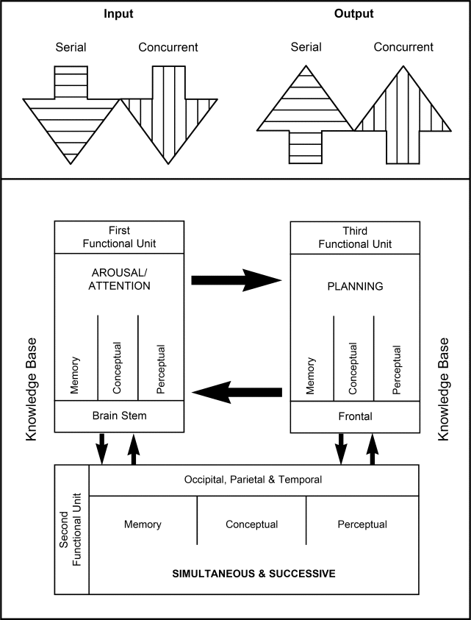
- Knowledge of the brain and theories governing information processing can determine the types of data collected during the assessment phase.
- For example, instead of simply observing whether the individual was successful at a task or set of measures, the practitioner looks beyond the product to determine the influence of related factors.
- These factors can include the nature of the stimuli used (visual, verbal, tactile), the method of presentation (visual, verbal, concrete, social), the type of response desired (verbal, motor, constructional), and the response time allowed (timed, untimed; Cooley & Morris, 1990).
- Information processing theory is the approach to the study of cognitive development evolved out of the American experimental tradition in psychology. Developmental psychologists who adopt the information processing perspective account for mental development in terms of maturational changes in basic components of a child's mind.
- The theory is based on the idea that humans process the information they receive, rather than merely responding to stimuli. This perspective uses an analogy to consider how the mind works like a computer.
- In this way, the mind functions like a biological computer responsible for analyzing information from the environment.
- According to the standard information-processing model for mental development, the mind's machinery includes attention mechanisms for bringing information in, working memory for actively manipulating information, and long-term memory for passively holding information so that it can be used in the future.This theory addresses how as children grow, their brains likewise mature, leading to advances in their ability to process and respond to the information they received through their senses.

Humans as Information Processing Systems
- The information processing theory simplified is comparing the human brain to a computer or basic processor. It is theorized that the brain works in a set sequence, as does a computer. The sequence goes as follows, "receives input, processes the information, and delivers an output".
- This theory suggests that we as humans will process information in a similar way. Like a computer receives input the mind will receive information through the senses. If the information is focused on, it will move to the short-term memory. While in the short-term memory or working memory, the mind is able to use the information to address its surroundings. The information is then encoded to the long-term memory, where the information is then stored.
- The information can be retrieved when necessary using the central executive. The central executive can be understood as the conscious mind. The central executive can pull information from the long-term memory back to the working memory for its use. As a computer processes information, this is how it is thought our minds are processing information. The output that a computer would deliver can be likened to the mind's output of information through behavior or action.

Components of the Information Processing Theory
- Though information processing can be compared to a computer, there is much more that needs to be explained. Information Processing has several components. The major components are information stores, cognitive processes, and executive cognition.
- Information stores are the different places that information can be stored in the mind. Information is stored briefly in the sensory memory. This information is stored just long enough for us to move the information to the short-term memory. George Armitage Miller discovered the short-term memory can only hold 7 (plus or minus two) things at once.
- The information here is also stored for only 15–20 seconds. The information stored in the short-term memory can be committed to the long-term memory store. There is no limit to the information stored in the long-term memory. The information stored here can stay for many years. Long-term memory can be divided between semantic, episodic, and procedural memories.
- The semantic memory is made up of facts or information learned or obtained throughout life. The episodic memory is made up of personal experiences or real events that have happened in a person's life.Last the procedural memory is made up of procedures or processes learned such as riding a bike. Each of these are subcategories of long-term memory.
- Cognitive processes are the way humans transfer information among the different memory stores. Some prominent processes used in transferring information are coding, retrieval, and perception.
- Coding is the process of transferring information from the short to long-term memory by relating the information of the long-term memory to the item in the short-term memory. This can be done through memorization techniques. Retrieval is used to bring information from the long-term memory back to the short-term memory. This can be achieved through many different recall techniques.
- Perception is the use of the information processed to interpret the environment. Another useful technique advised by George Miller is recoding. Recoding is the process of regrouping or organizing the information the mind is working with. A successful method of recoding is chunking.
- Chunking is used to group together pieces of information. Each unit of information is considered a chunk, this could be one or several words.This is commonly used when trying to memorize a phone number.
- Executive cognition is the idea that someone is aware of the way they process information. They know their strengths and weaknesses. This concept is similar to metacognition. The conscious mind has control over the processes of the information processing theory.

Emergence
- Information processing as a model for human thinking and learning is part of the resurgence of cognitive perspectives of learning.
- The cognitive perspective asserts that complex mental states affect human learning and behavior that such mental states can be scientifically investigated. Computers, which process information, include internal states that affect processing.
- Computers, therefore, provided a model for possible human mental states that provided researchers with clues and direction for understanding human thinking and learning as information processing.
- Overall, information-processing models helped reestablish mental processes –– processes that cannot be directly observed –– as a legitimate area of scientific research.
- George Armitage Miller was one of the founders of the field of psychology known as cognition. He played a large role when it came to the Information Processing theory. He researched the capacity of the working memory discovering that people can only hold up to 7 plus or minus 2 items. He also created the term chunking when explaining how to make the most of our short-term memory.
- Two other theorists associated with the Cognitive Information Processing Theory are Richard C. Atkinson and Richard Shiffrin. In 1968 these two proposed a multi-stage theory of memory. They explained that from the time information is received by the processing system, it goes through different stages to be fully stored. They broke this down to sensory memory, short-term memory, and long-term memory (Atkinson).
- Later in 1974 Alan Baddeley and Graham Hitch would contribute more to the information processing theory through their own discoveries. They deepened the understanding of memory through the central executive, phonological loop, and visuospatial sketch pad. Baddeley later updated his model with the episodic buffer.
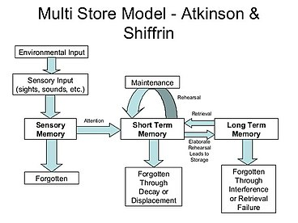
- The Atkinson and Shiffrin Model was proposed in 1968 by Richard C. Atkinson and Richard Shiffrin. This model illustrates their theory of the human memory. These two theorists used this model to show that the human memory can be broken in to three sub-sections: Sensory Memory, short-term memory and long-term memory.^{[9]}

Sensory Memory
- The sensory memory is responsible for holding onto information that the mind receives through the senses such as auditory and visual information. For example, if someone were to hear a bird chirp, they know that it is a bird because that information is held in the brief sensory memory.

Short-Term Memory
- Short-term memory lasts for about 30 seconds. Short-term memory retains information that is needed for only a short period of time such as remembering a phone number that needs to be dialed.

Long-Term Memory
- The long-term memory has an unlimited amount of space. In the long-term memory, there can be memory stored in there from the beginning of our life time. The long-term memory is tapped into when there is a need to recall an event that happened in an individual's previous experiences.

Baddeley and Hitch Model of Working Memory
- Baddeley and Hitch introduced the model of working memory in 1974. Through their research, they contributed more to help understand how the mind may process information. They added three elements that explain further cognitive processes. These elements are the central executive, phonological loop, and the visuo-spatial working memory. Later Alan Baddeley added a fourth element to the working memory model called the episodic buffer. Together these ideas support the information processing theory and possibly explain how the mind processes information.
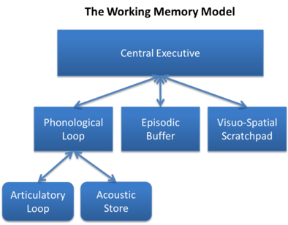

Central Executive
- The central executive is a flexible system responsible for the control and regulation of cognitive processes. It directs focus and targets information, making working memory and long-term memory work together. It can be thought of as a supervisory system that controls cognitive processes, making sure the short-term store is actively working, and intervenes when they go astray and prevents distractions.
It has the following functions:
- updating and coding incoming information and replacing old information binding information from a number of sources into coherent episodes coordination of the slave systems shifting between tasks or retrieval strategies inhibition, suppressing dominant or automatic responses selective attention The central executive has two main systems: the visuo-spatial sketchpad, for visual information, and the phonological loop, for verbal information.
- Using the dual-task paradigm, Baddeley and Erses have found, for instance, that patients with Alzheimer's dementia are impaired when performing multiple tasks simultaneously, even when the difficulty of the individual tasks is adapted to their abilities.Two tasks include a memory tasks and a tracking task. Individual actions are completed well, but as the Alzheimer's becomes more prominent in a patient, performing two or more actions becomes more and more difficult. This research has shown the deteriorating of the central executive in individuals with Alzheimer's.
- Recent research on executive functions suggests that the 'central' executive is not as central as conceived in the Baddeley & Hitch model. Rather, there seem to be separate executive functions that can vary largely independently between individuals and can be selectively impaired or spared by brain damage

Phonological Loop
- Working in connection with the central executive is the phonological loop. The phonological loop is used to hold auditory information. There are two sub components of the phonological loop; the phonological store and the articulatory rehearsal process. The phonological store holds auditory information for a short period. The articulatory rehearsal process keeps the information in the store for a longer period of time through rehearsal.

Visuospatial Sketch Pad
- The visuospatial sketch pad is the other portion of the central executive. This is used to hold visual and spatial information. The visuospatial sketch pad is used to help the conscious imagine objects as well as maneuver through the physical environment.

Episodic Buffer
- Baddeley later added a fourth aspect to the model called the episodic buffer. It is proposed that the episodic buffer is able to hold information thereby increasing the amount stored. Due to the ability to hold information the episodic buffer is said to also transfer information between perception, short-term memory and long-term memory. The episodic buffer is a relatively new idea and is still being researched.

Other Cognitive processes
- Cognitive processes include perception, recognition, imagining, remembering, thinking, judging, reasoning, problem solving, conceptualizing, and planning. These cognitive processes can emerge from human language, thought, imagery, and symbols.
- In addition to these specific cognitive processes, many cognitive psychologists study language-acquisition, altered states of mind and consciousness, visual perception, auditory perception, short-term memory, long-term memory, storage, retrieval, perceptions of thought and much more.
- Cognitive processes emerge through senses, thoughts, and experiences. The first step is aroused by paying attention, it allows processing of the information given. Cognitive processing cannot occur without learning, they work hand in hand to fully grasp the information.cognitive process

Nature versus nurture
- Nature versus nurture refers to the theory about how people are influenced. The nature mentality is around the idea that we are influenced by our genetics. This involves all of our physical characteristics and our personality.
- On the other hand, nurture revolves around the idea that we are influenced by the environment and our experiences. Some believe that we are the way we are due to how we were raised, in what type of environment we were raised in and our early childhood experiences. This theory views humans as actively inputting, retrieving, processing, and storing information.
- Context, social content, and social influences on processing are simply viewed as information. Nature provides the hardware of cognitive processing and Information Processing theory explains cognitive functioning based on that hardware.
- Individuals innately vary in some cognitive abilities, such a memory span, but human cognitive systems function similarly based on a set of memory stores that store information and control processes determine how information is processed. The “Nurture” component provides information input (stimuli) that is processed resulting in behavior and learning. Changes in the contents of the long-term memory store (knowledge) are learning. Prior knowledge affects future processing and thus affects future behavior and learning.

Quantitative versus qualitative
- Information processing theory combines elements of both quantitative and qualitative development. Qualitative development occurs through the emergence of new strategies for information storage and retrieval, developing representational abilities (such as the utilization of language to represent concepts), or obtaining problem-solving rules (Miller, 2011).
- Increases in the knowledge base or the ability to remember more items in working memory are examples of quantitative changes, as well as increases in the strength of connected cognitive associations (Miller, 2011). The qualitative and quantitative components often interact together to develop new and more efficient strategies within the processing system.

Current areas of research
Information Processing Theory is currently being utilized in the study of computer or artificial intelligence. This theory has also been applied to systems beyond the individual, including families and business organizations. For example, Ariel (1987) applied Information Processing Theory to family systems, with sensing, attending, and encoding of stimuli occurring either within individuals or within the family system itself. Unlike traditional systems theory, where the family system tends to maintain stasis and resists incoming stimuli which would violate the system's rules, the Information Processing family develops individual and mutual schemes which influence what and how information is attended to and processed. Dysfunctions can occur both at the individual level as well as within the family system itself, creating more targets for therapeutic change. Rogers, P. R. et al. (1999) utilized Information Processing Theory to describe business organizational behavior, as well as to present a model describing how effective and ineffective business strategies are developed. In their study, components of organizations that "sense" market information are identified as well as how organizations attend to this information; which gatekeepers determine what information is relevant/important for the organization, how this is organized into the existing culture (organizational schemas), and whether or not the organization has effective or ineffective processes for their long-term strategy. Cognitive psychologist, Kahnemen and Grabe, noted that learners has some control over this process. Selective attention is the ability of humans to select and process certain information while simultaneously ignoring others. This is influenced by many things including:
- What the information being processed means to the individual
- The complexity of the stimuli (based partially on background knowledge)
- Ability to control attention (varies based on age, hyperactivity, etc.)
Some research has shown that individuals with a high working memory are better able to filter out irrelevant information. In particular, one study on focusing on dichotic listening, followed participants were played two audio tracks, one in each ear, and were asked to pay attention only to one. It was shown that there was a significant positive relationship between working memory capacity and ability of the participant to filter out the information from the other audio track.

SHORT-TERM MEMORY:
- ‘Short-term memory’ refers to a number of systems with limited capacity (in the verbal domain, roughly the ‘magical’ number 72 items: Miller 1956) concerned with the temporary retention (in the range of seconds) of a variety of materials.
- Knowledge of the functional and anatomical organization of short-term memory in humans, and its role in cognition as at the turn of the twenty-first century, is herewith presented, drawing data from three main sources of evidence:
- (a) behavioral studies in normal individuals and in braininjured patients with selective neuropsychological short-term memory deficits;
- (b) correlations between the anatomical localization of the cerebral lesion and the short-term memory disorder of brain-damaged patients;
- (c) correlations between the activation of specific cerebral areas and the execution of tasks assessing short-term retention in normal subjects. The two more extensively investigated aspects of shortterm memory are considered: verbal and visual spatial. ‘Short-term memory’ is closely related to the concept of ‘working memory’ (see Working Memory, Psychology of Working Memory, Neural Basis of).
- The present article focuses on the ‘storage’ and ‘rehearsal’ components of the system, rather than on the cognitive operations and executive functions currently associated with ‘working memory.’
- However, the section devoted to the uses of short-term memory illustrates some of the working aspects of short-term retention..
Historical Origin of the Construct ‘Short-term Memory’ Suggestions of a distinction between two types of memory, one concerned with temporary retention, and the other having the function of a storehouse for materials which have been laid out of sight, date back at least to John Locke’s ‘Essay Concerning Human Understanding’ (1700).
- William James (1895) revived the distinction, suggesting the existence of a limitedcapacity ‘primary memory,’ embracing the present and the immediate past, and subserving consciousness (see Consciousness, Neural Basis of). Psychological research in the nineteenth century and in the first half of the twentieth century was, however, mainly concerned with the diverse factors affecting learning and retention, in the context of a basically unitary view of human memory.
- It was only in the 1950s that shortterm memory became the object of systematic behavioral studies in normal subjects (Baddeley 1976). In the late 1960s the division of human memory into a short- and a long-term system became a current view (Atkinson and Shiffrin 1968) backwards by threes.
- (b) In the immediate free recall of a sequence of events, such as words, the final five to six stimuli on the list are recalled better that the preceding ones. This ‘recency effect’ vanishes after a few seconds of distracting activity, and is minimally affected by factors such as age, rate of presentation of the stimuli, and word frequency.
- (c) In the immediate serial recall of verbal material (memory span), the subject’s performance is affected by factors such as phonological similarity and word length, with the effects of semantic factors being comparatively minor.
- Each of these phenomena subsequently proved to be considerably more complex than initially thought. They were also interpreted as compatible with a unitary, single-system, view of human memory.
- This account proved untenable, however, mainly on the basis of neuropsychological evidence. These empirical observations illustrate the main characteristics of ‘short-term memory’: a retention system with limited capacity, where the memory trace, in the time range of seconds, shows a decay, which may be prevented through rehearsal. Material stored in short-term memory has a specific representational format, which, in the case of the extensively-investigated verbal domain, involves phonological codes, separately from lexical-semantic representations stored in long-term memory.
- The latter contribute, however, to immediate retention, e.g., in verbal span tasks. The functional architecture of phonological shortterm memory has been investigated in detail using effects which break down storage and rehearsal subcomponents.
- The effect of phonological similarity, whereby the immediate serial recall of auditory and visual verbal material is poorer for sequences of phonologically similar stimuli than for dissimilar ones, reflects the coding which takes place in the phonological short-term store.
- The effect of word length, whereby the immediate serial recall of auditory and visual verbal material is poorer for sequences of long words than for short ones, is held to reflect the activity of the process of rehearsal, abolished by ‘articulatory suppression,’ i.e., a continuous uttering of an irrelevant speech sound. Suppression, while disrupting rehearsal, also reduces immediate memory performance in span tasks.
- The interaction between phonological similarity, input modality and articulatory suppression, with suppression abolishing phonological similarity only when the stimuli are presented visually, suggests that rehearsal participates in the process of conveying visual verbal material to the phonological short-term store. Finally, some phonological judgments (such as rhyme and stress assignment) are held to involve the articulatory components of rehearsal, because the performance of normal subjects is selectively impaired by suppression (Burani et al. 1991).
. The Uses of Short-term Memory Is there a use for a system providing the temporary retention of a limited amount of stimuli, besides infrequent situations such as the following? A friend tells us an unfamiliar eight-digit number, which we have to dial on a telephone placed on the other side of a large street and we have no paper and pencil to write it down. The answer is positive. Short-term retention contributes to the stable acquisition of new information in long-term memory. More specifically, phonological short-term memory plays an important role in learning new vocabulary and participates in the processes of speech comprehension and production (see Speech Perception; Speech Production, Psychology of).
Long-term Learning The observation that patients with defective auditoryverbal span are also impaired in learning unfamiliar pronounceable letter sequences gives rise to the possibility that phonological memory may contribute to a relevant aspect of language development, the acquisition of vocabulary (Fig. 2). Similarly, subjects with a developmental deficit of phonological memory are impaired in vocabulary acquisition and in non-word learning. An opposite pattern is provided by subjects with a congenital cognitive impairment which selectively spares phonological short-term memory. Acquisition of vocabulary, foreign languages and nonword learning are also preserved. Converging evidence from different subject populations supports this view. Correlational studies in children have shown that the capacity of phonological memory is a main predictor of the subsequent acquisition of vocabulary, both in the native and in a second language. In normal adult subjects, the variables which disrupt immediate memory span (phonological similarity, item length, articulatory suppression) also impair the acquisition of non-words. Polyglots have a greater capacity of phonological memory, compared to nonpolyglots, and a better ability to learn novel words. Phonological short-term memory may be considered as a learning device for the acquisition of novel phonological representations, and the building up of the phonological lexicon (Baddeley et al. 1998). A few observations in brain-damaged patients suggest a similar role for visuo-spatial shortterm memory in the acquisition of new visual information, such as unfamiliar faces and objects.

https://en.wikipedia.org/wiki/Information_processing_theory

https://sci-hub.se/https://www.sciencedirect.com/science/article/abs/ pii/B0080430767035154

